

**SCHOOL OF COMPUTER SCIENCE ENGINEERING**

**AND INFORMATION SYSTEMS**

**FALL SEMESTER 2024-2025**

**PMCA503P – DATABASE SYSTEMS LAB**

**CYCLESHEET – SQL**

**SUBMITTED ON: 08 – SEPT - 2024**

**SUBMITTED BY-**

**AKASH KUMAR BANIK**

**PROGRAM: MCA**

**REGISTER No.: 24MCA0242**

**CYCLESHEET – SQL**

Consider the following relational database schema for teaching-learning process in a university.

(Source: Database Systems – Coronel & Morris)

PROFESSOR(Prof_id, Prof_name, Email, Mobile, Specialty, Dept_id)

SCHOOL(SCode, Scl_name, Prof_id, Location)

DEPARTMENT(Dept_id, Dname, SCode, Prof_id)

COURSE(Crs_code, Crs_name, Description, Credits, Hours)

CLASS(Cls_code, Slot, Stime, Etime, Crs_code, Prof_id, Room_no, Sem_code, Day_of_week)

SEMESTER(Sem_code, Term, Year, Sdate, Edate)

STUDENT(Reg_no, Sname, Address, DoB, Email, Mobile, Dept_id, Prof_id)

ENROLL(Cls_code, Reg_no, Enroll_time, Grade)

STUDENT_VISA(Reg_no, Visa_status)

PROGRAMME(Prog_code, Prog_name, Prog_preamble, Scode, Dept_id)

The primary keys are underlined and foreign keys are self-explanatory. The Dept_id column in professor table stands for the department the professor belongs to and Prof_id column in the school table stands for the professor who chairs the school, the same column in the department table stands for the professor who heads the department, the domain of Term column in semester table is {Winter, Fall}.

**1. Create the above tables.**

**PROFESSOR TABLE:**

CREATE TABLE PROFESSOR_24MCA0242 (

    Prof_id VARCHAR2(5),

    Prof_name VARCHAR2(30) NOT NULL,

    Email VARCHAR2(30) NOT NULL,

    Mobile NUMBER(10) NOT NULL,

    Specialty VARCHAR2(30),

    Dept_id VARCHAR2(5),

    CONSTRAINT pk_professor PRIMARY KEY (Prof_id),

    CONSTRAINT uq_prof_email UNIQUE (Email),

    CONSTRAINT uq_prof_mobile UNIQUE (Mobile),

    CONSTRAINT ck_prof_email CHECK (INSTR(Email, '@') > 1),

    CONSTRAINT ck_prof_mobile CHECK (LENGTH(Mobile) = 10)

);

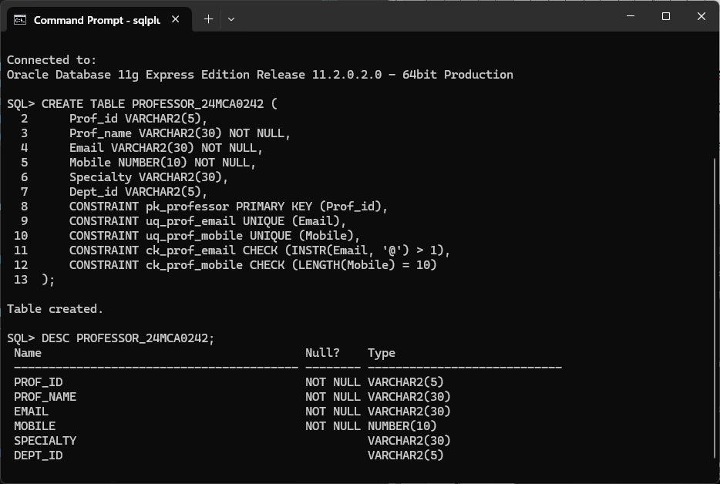

**SCHOOL TABLE:**

CREATE TABLE SCHOOL_24MCA0242 (

    SCode VARCHAR2(5),

    Scl_name VARCHAR2(10) NOT NULL,

    Prof_id VARCHAR2(5),

    Location VARCHAR2(50),

    CONSTRAINT pk_school PRIMARY KEY (SCode),

CONSTRAINT fk_school_prof FOREIGN KEY (Prof_id) REFERENCES PROFESSOR_24MCA0242 (Prof_id)

); 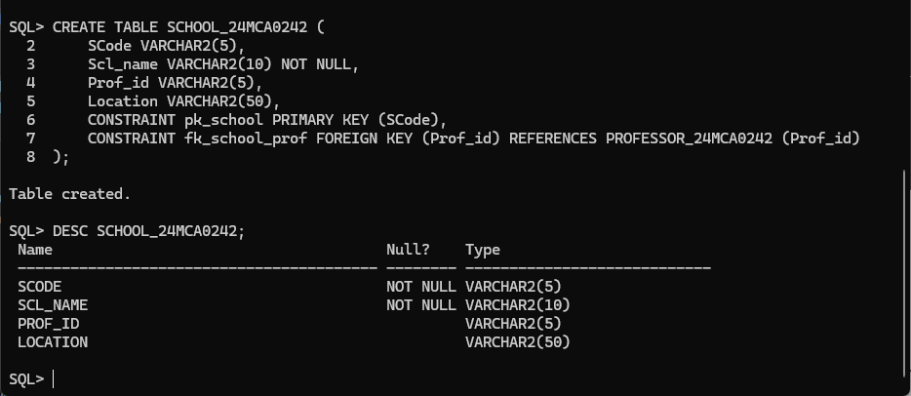

**DEPARTMENT TABLE:**

CREATE TABLE DEPARTMENT_24MCA0242 (

    Dept_id VARCHAR2(5),

    Dname VARCHAR2(50) NOT NULL,

    SCode VARCHAR2(5),

    Prof_id VARCHAR2(5),

    CONSTRAINT pk_department PRIMARY KEY (Dept_id),

CONSTRAINT fk_dept_school FOREIGN KEY (SCode) REFERENCES SCHOOL_24MCA0242 (SCode),

CONSTRAINT fk_dept_prof FOREIGN KEY (Prof_id) REFERENCES PROFESSOR_24MCA0242 (Prof_id)

);

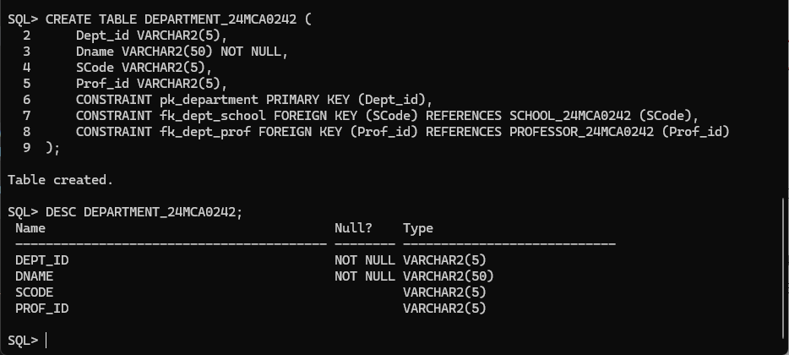

**COURSE TABLE:**

CREATE TABLE COURSE_24MCA0242 (

    Crs_code VARCHAR2(5),

    Crs_name VARCHAR2(50) NOT NULL,

    Description VARCHAR2(50),

    Credits NUMBER(2) NOT NULL,

    Hours NUMBER(3) NOT NULL,

    CONSTRAINT pk_course PRIMARY KEY (Crs_code)

);

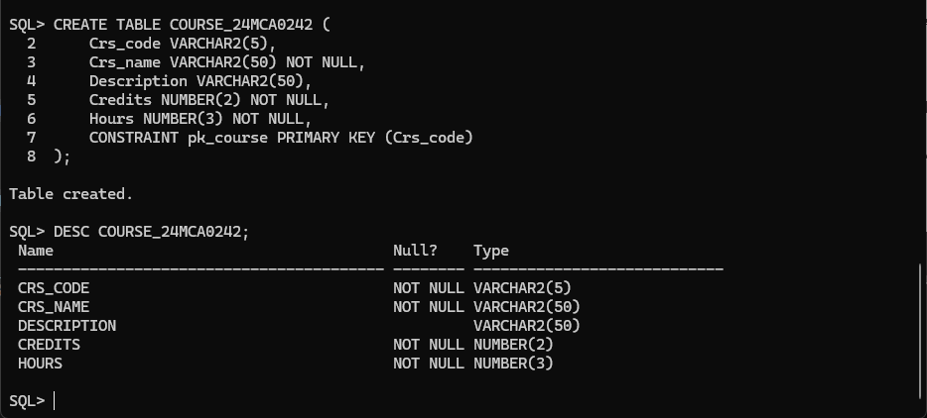

**STUDENT TABLE:**

CREATE TABLE STUDENT_24MCA0242 (

    Reg_no VARCHAR2(5),

    Sname VARCHAR2(30) NOT NULL,

    Address VARCHAR2(50),

    DoB DATE NOT NULL,

    Email VARCHAR2(30) NOT NULL,

    Mobile NUMBER(10) NOT NULL,

    Dept_id VARCHAR2(5),

    Prof_id VARCHAR2(5),

    CONSTRAINT pk_student PRIMARY KEY (Reg_no),

CONSTRAINT fk_student_dept FOREIGN KEY (Dept_id) REFERENCES DEPARTMENT_24MCA0242 (Dept_id),

CONSTRAINT fk_student_prof FOREIGN KEY (Prof_id) REFERENCES PROFESSOR_24MCA0242 (Prof_id),

    CONSTRAINT uq_student_email UNIQUE (Email),

    CONSTRAINT uq_student_mobile UNIQUE (Mobile),

    CONSTRAINT ck_student_email CHECK (INSTR(Email, '@') > 1),

    CONSTRAINT ck_student_mobile CHECK (LENGTH(Mobile) = 10)

);

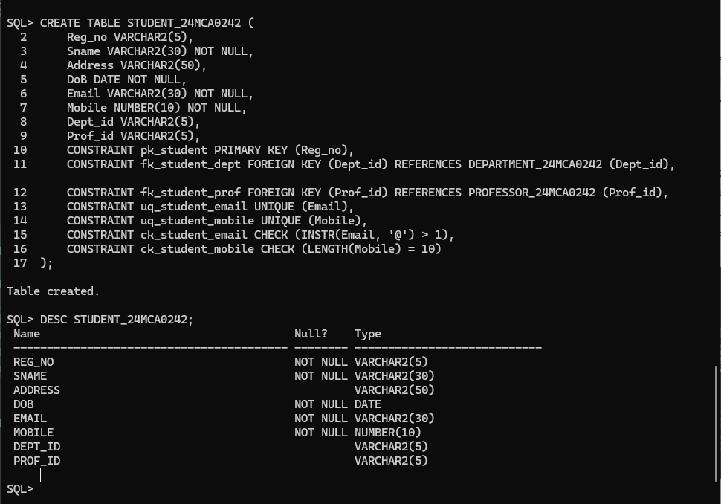

**PROGRAMME TABLE:**

CREATE TABLE PROGRAMME_24MCA0242 (

    Prog_code VARCHAR2(5),

    Prog_name VARCHAR2(30) NOT NULL,

    Prog_preamble VARCHAR2(50),

    Scode VARCHAR2(5),

    Dept_id VARCHAR2(5),

    CONSTRAINT pk_programme PRIMARY KEY (Prog_code),

CONSTRAINT fk_prog_school FOREIGN KEY (Scode) REFERENCES SCHOOL_24MCA0242 (SCode),

CONSTRAINT fk_prog_dept FOREIGN KEY (Dept_id) REFERENCES DEPARTMENT_24MCA0242 (Dept_id)

);

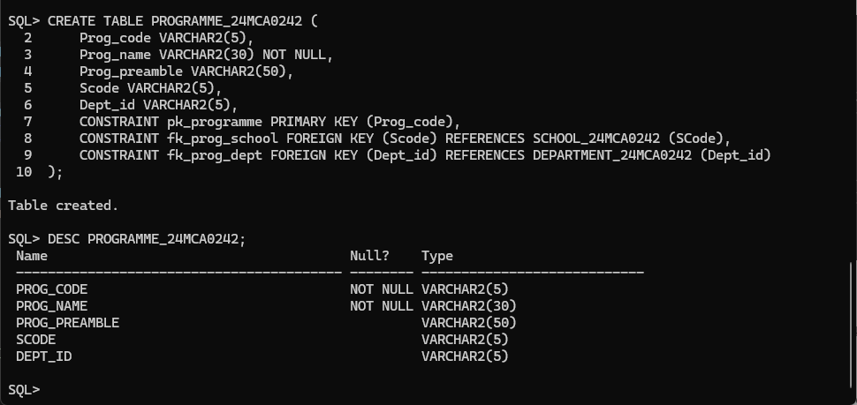

**SEMESTER TABLE:**

CREATE TABLE SEMESTER_24MCA0242 (

    Sem_code VARCHAR2(10),

    Term VARCHAR2(5) CHECK (Term IN ('Winter', 'Fall')),

    Year NUMBER(4) NOT NULL,

    Sdate DATE NOT NULL,

    Edate DATE NOT NULL,

    CONSTRAINT pk_semester PRIMARY KEY (Sem_code),

CONSTRAINT ck_sem_code CHECK (Sem_code LIKE 'Win%' OR Sem_code LIKE 'Fall%')

);

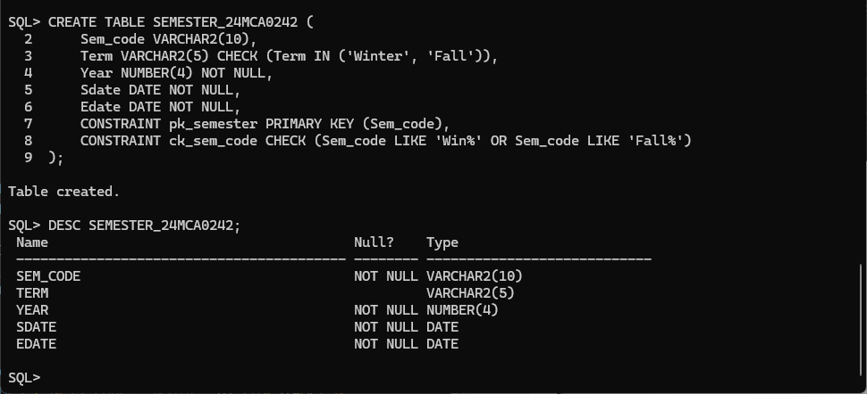



**CLASS TABLE:**

CREATE TABLE CLASS_24MCA0242 (

    Cls_code VARCHAR2(5),

    Slot VARCHAR2(10) NOT NULL,

    Stime TIMESTAMP(0) NOT NULL,

    Etime TIMESTAMP(0) NOT NULL,

    Crs_code VARCHAR2(5),

    Prof_id VARCHAR2(5),

    Room_no VARCHAR2(10),

    Sem_code VARCHAR2(10),

    Day_of_week VARCHAR2(10),

    CONSTRAINT pk_class PRIMARY KEY (Cls_code),

CONSTRAINT fk_class_course FOREIGN KEY (Crs_code) REFERENCES COURSE_24MCA0242 (Crs_code),

CONSTRAINT fk_class_prof FOREIGN KEY (Prof_id) REFERENCES PROFESSOR_24MCA0242 (Prof_id),

CONSTRAINT fk_class_sem FOREIGN KEY (Sem_code) REFERENCES SEMESTER_24MCA0242 (Sem_code)

);

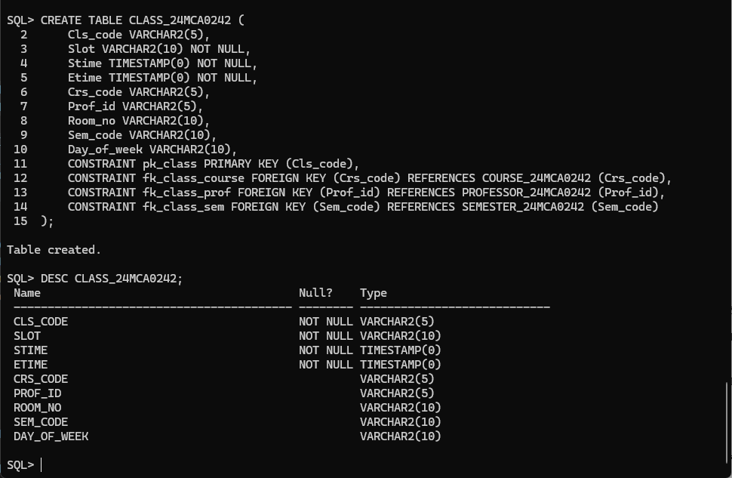

**ENROLL TABLE:**

CREATE TABLE ENROLL_24MCA0242 (

    Cls_code VARCHAR2(5),

    Reg_no VARCHAR2(5),

    Enroll_time TIMESTAMP(0) NOT NULL,

    Grade CHAR(1) CHECK (Grade IN ('S', 'A', 'B', 'C', 'D')),

    CONSTRAINT pk_enroll PRIMARY KEY (Cls_code, Reg_no),

CONSTRAINT fk_enroll_class FOREIGN KEY (Cls_code) REFERENCES CLASS_24MCA0242 (Cls_code) ON DELETE CASCADE,

CONSTRAINT fk_enroll_student FOREIGN KEY (Reg_no) REFERENCES STUDENT_24MCA0242 (Reg_no) ON DELETE CASCADE

);

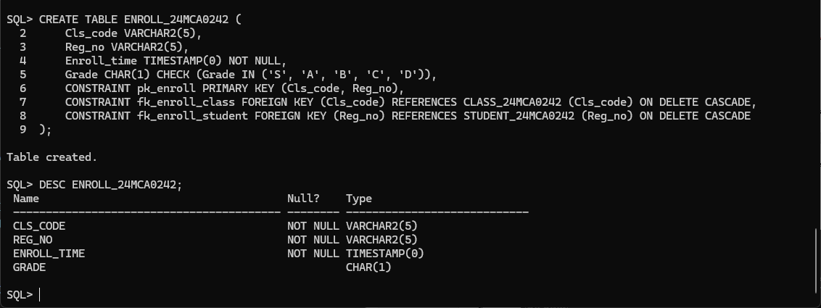

**STUDENT_VISA TABLE:**

CREATE TABLE STUDENT_VISA_24MCA0242 (

    Reg_no VARCHAR2(5),

    Visa_status VARCHAR2(10),

    CONSTRAINT pk_student_visa PRIMARY KEY (Reg_no),

CONSTRAINT fk_student_visa FOREIGN KEY (Reg_no) REFERENCES STUDENT_24MCA0242 (Reg_no)

);

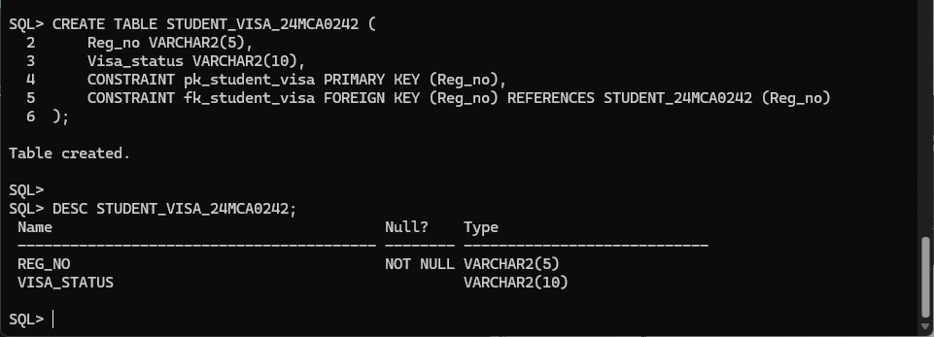

**2. Enter data into the above tables. Display the content of each table. Use column formatting while displaying.**

**PROFESSOR TABLE:**

INSERT INTO PROFESSOR_24MCA0242 (Prof_id, Prof_name, Email, Mobile, Specialty, Dept_id) VALUES ('&Prof_id','&Prof_name','&Email','&Mobile','&Specialty','&Dept_id');

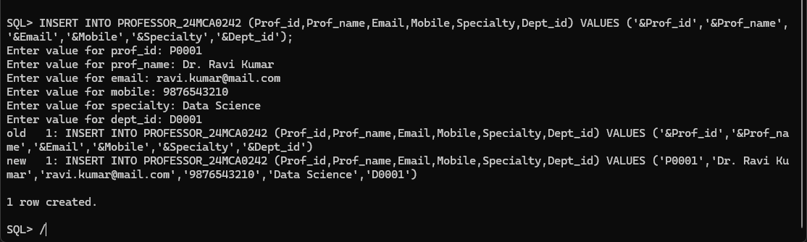

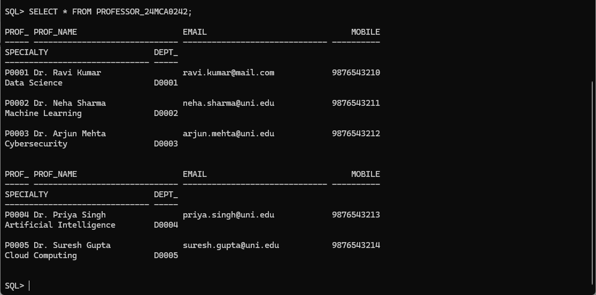

**SCHOOL TABLE:**

INSERT INTO SCHOOL_24MCA0242 (Scode, Scl_name, Prof_id, Location) VALUES ('&Scode', '&Scl_name', '&Prof_id', '&Location');

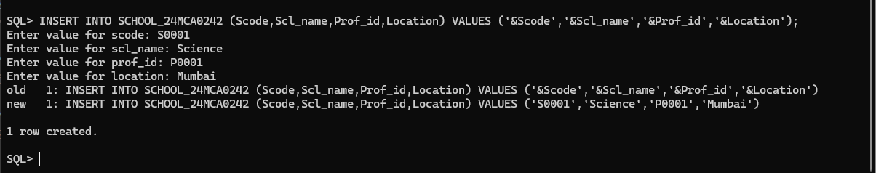

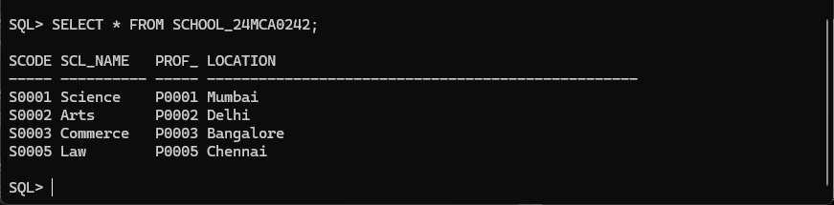

**DEPARTMENT TABLE:**

INSERT INTO DEPARTMENT_24MCA0242 (Dept_id, Dname, Scode, Prof_id) VALUES ('&Dept_id', '&Dname', '&Scode', '&Prof_id');

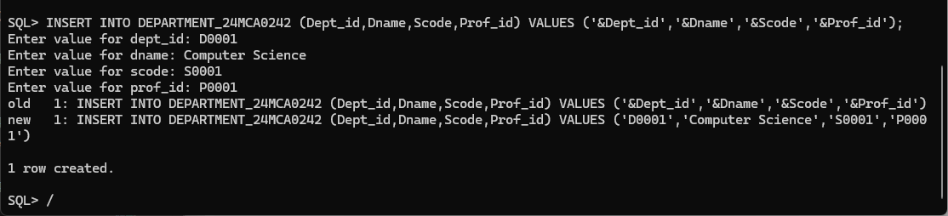

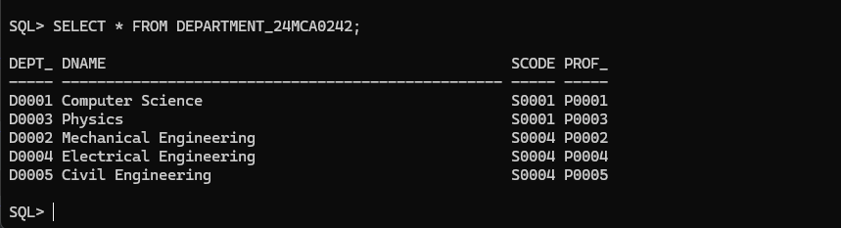

**COURSE TABLE:**

INSERT INTO COURSE_24MCA0242 (Crs_code, Crs_name, Description, Credits, Hours) VALUES ('&Crs_code', '&Crs_name', '&Description', '&Credits', '&Hours');

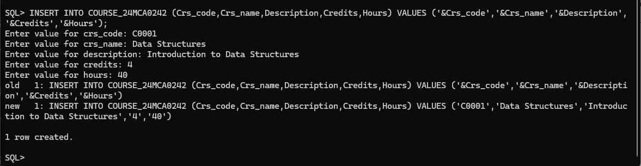

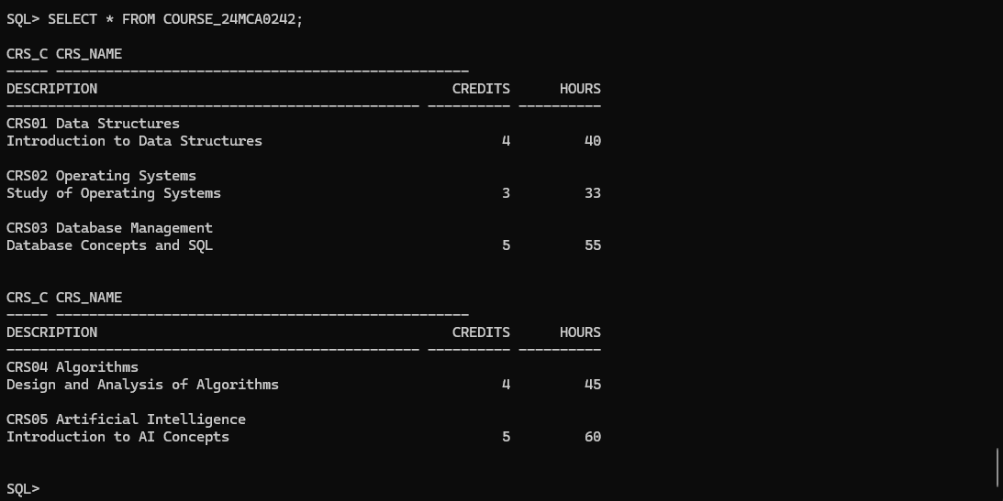

**STUDENT TABLE:**

INSERT INTO STUDENT_24MCA0242 (Reg_no, Sname, Address, DoB, Email, Mobile, Dept_id, Prof_id) VALUES ('&Reg_no', '&Sname', '&Address', TO_DATE('&DoB','YYYY-MM-DD'), '&Email', '&Mobile', '&Dept_id', '&Prof_id');

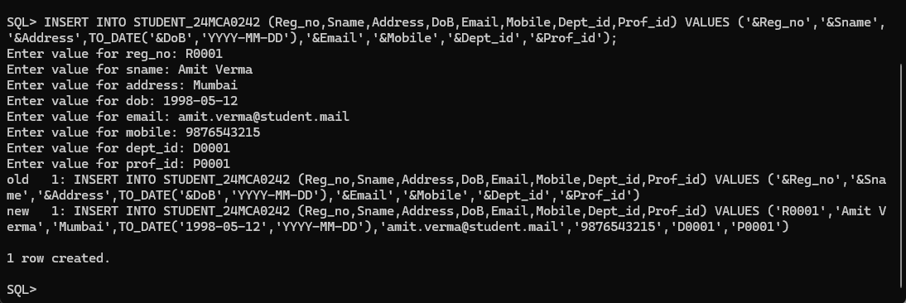

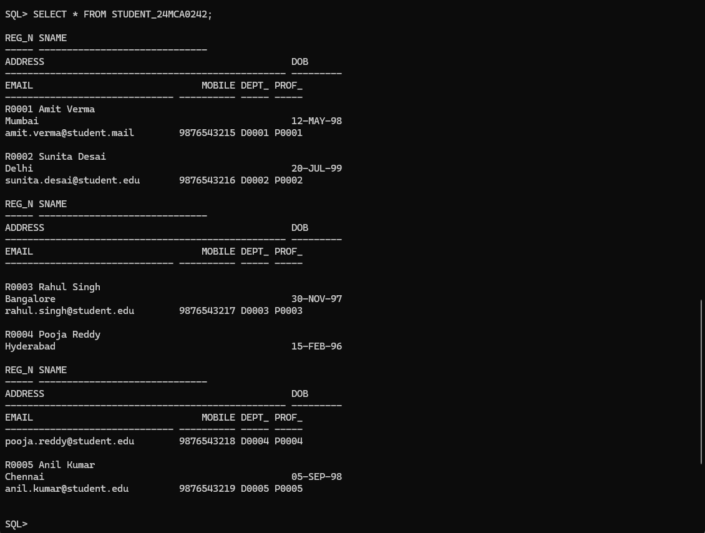

**PROGRAMME TABLE:**

INSERT INTO PROGRAMME_24MCA0242 (Prog_code, Prog_name, Prog_preamble, Scode, Dept_id) VALUES ('&Prog_code', '&Prog_name', '&Prog_preamble', '&Scode', '&Dept_id');

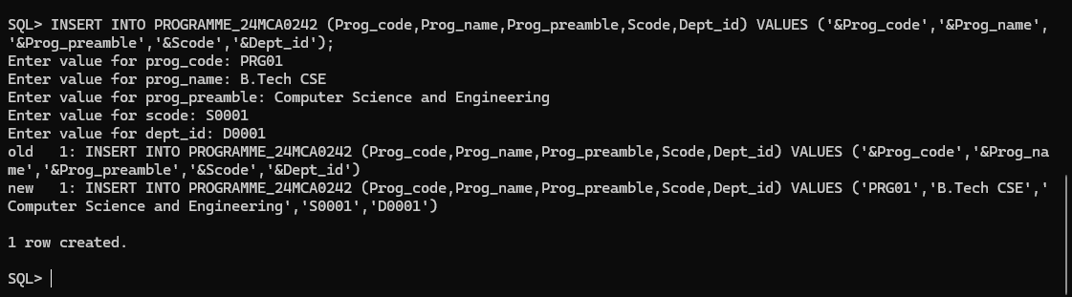

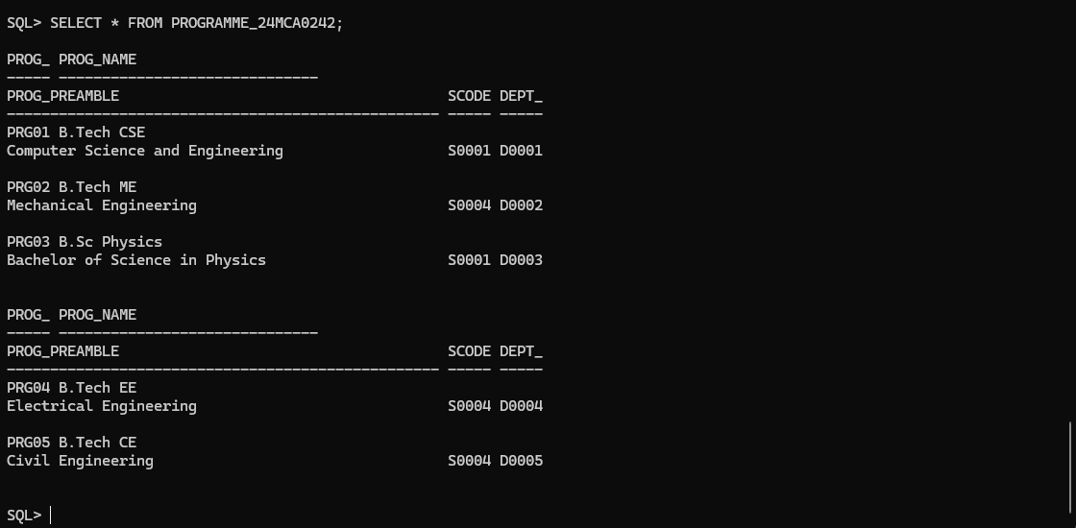

**SEMESTER TABLE:**

INSERT INTO SEMESTER_24MCA0242 (Sem_code, Term, Year, Sdate, Edate) VALUES ('&Sem_code','&Term','&Year', TO_DATE('&Sdate', 'YYYY-MM-DD'), TO_DATE('&Edate', 'YYYY-MM-DD'));

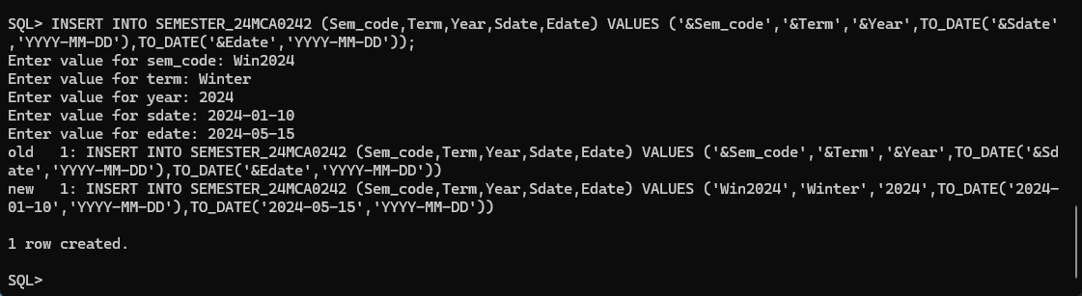

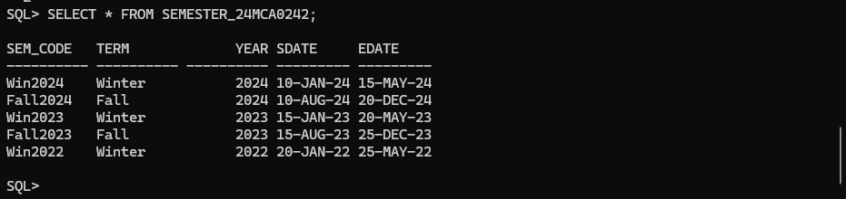

**CLASS TABLE:**

INSERT INTO CLASS_24MCA0242 (Cls_code, Slot, Stime, Etime, Crs_code, Prof_id, Room_no, Sem_code, Day_of_week) VALUES ('&Cls_code', '&Slot', TO_TIMESTAMP('&Stime', 'YYYY-MM-DD HH24:MI:SS'), TO_TIMESTAMP('&Etime', 'YYYY-MM-DD HH24:MI:SS'), '&Crs_code', '&Prof_id', '&Room_no', '&Sem_code', '&Day_of_week');

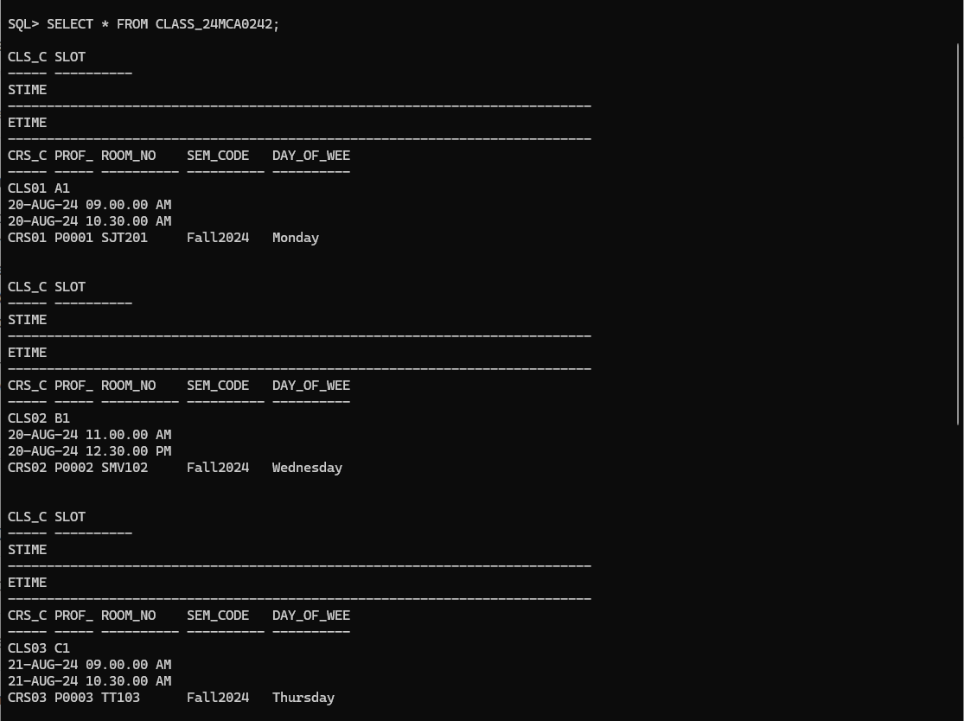

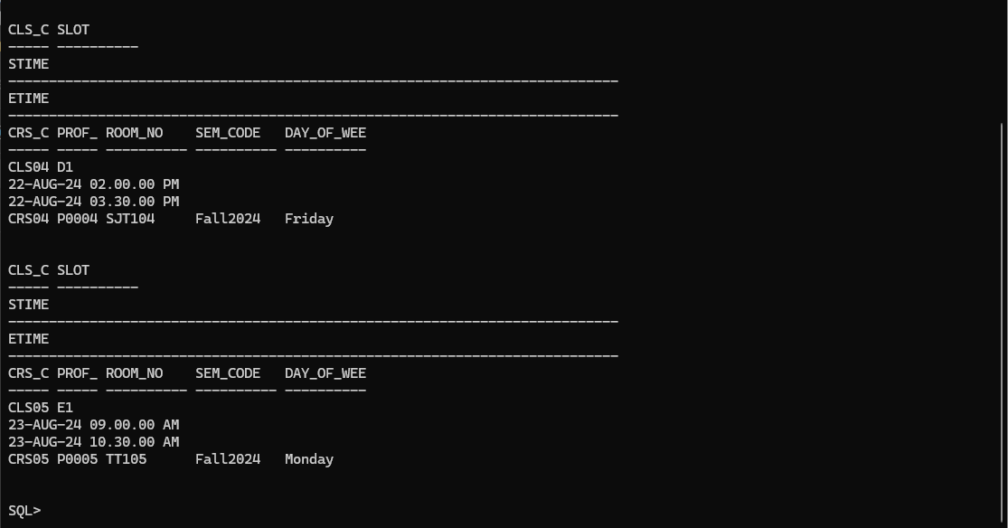

**ENROLL TABLE:**

INSERT INTO ENROLL_24MCA0242 (Cls_code, Reg_no, Enroll_time, Grade) VALUES ('&Cls_code', '&Reg_no', TO_TIMESTAMP('&Enroll_time','YYYY-MM-DD HH24:MI:SS'), '&Grade');

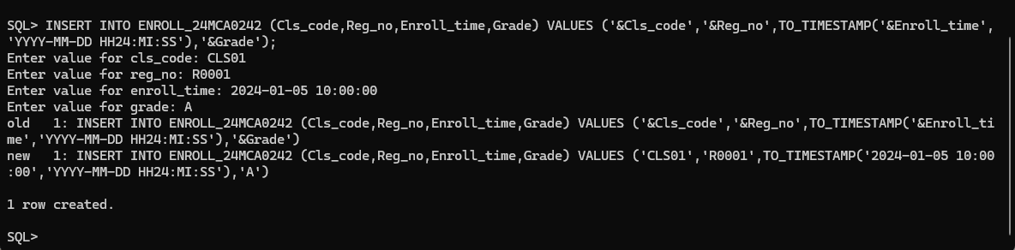

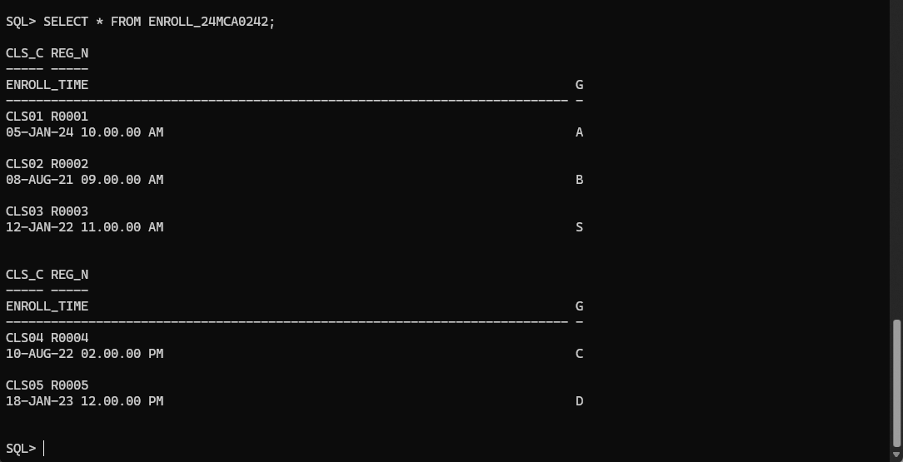

**STUDENT_VISA TABLE:**

INSERT INTO STUDENT_VISA_24MCA0242 (Reg_no, Visa_status) VALUES ('&Reg_no', '&Visa_status');

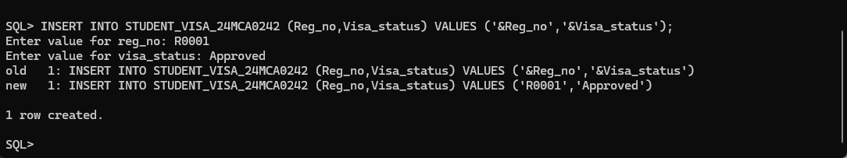

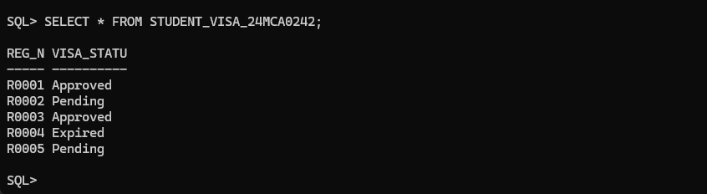

**3. Alter or Recreate the above tables with primary key and foreign key and the following integrity constraints assigning name to integrity constraint.**

1. Prof_id must have exactly five characters and their email and mobile number are unique. The email address must have @ as one of the characters and mobile number must have exactly ten characters.

ALTER TABLE PROFESSOR_24MCA0242

ADD CONSTRAINT ck_prof_id_length CHECK (LENGTH(Prof_id) = 5);

ALTER TABLE PROFESSOR_24MCA0242

ADD CONSTRAINT uq_prof_email UNIQUE (Email);

ALTER TABLE PROFESSOR_24MCA0242

ADD CONSTRAINT uq_prof_mobile UNIQUE (Mobile);

ALTER TABLE PROFESSOR_24MCA0242

ADD CONSTRAINT ck_prof_email CHECK (INSTR(Email, '@') > 1);

ALTER TABLE PROFESSOR_24MCA0242

ADD CONSTRAINT ck_prof_mobile CHECK (LENGTH(Mobile) = 10);

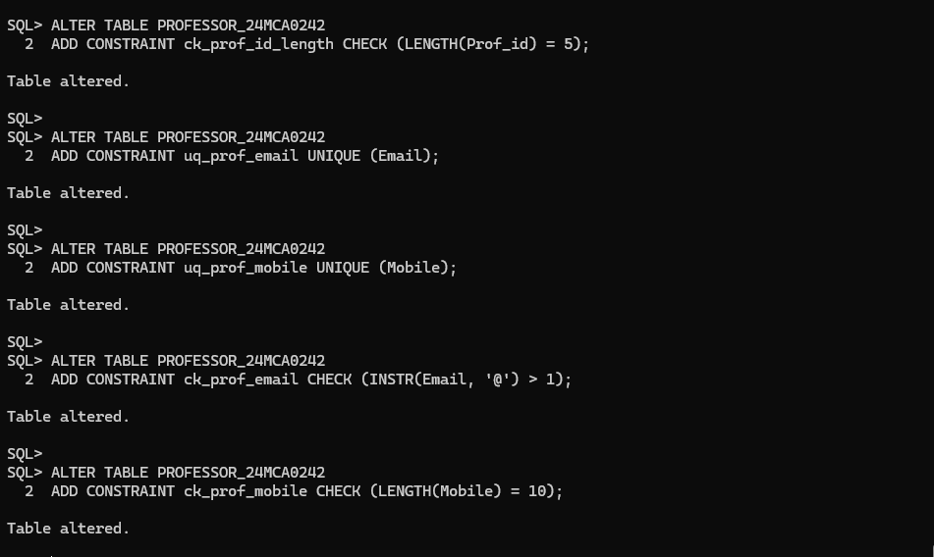

1. Use timestamp data type without fractional parts of seconds for start time and end time column of class table.

ALTER TABLE CLASS_24MCA0242 MODIFY (Stime TIMESTAMP(0));

ALTER TABLE CLASS_24MCA0242 MODIFY (Etime TIMESTAMP(0));

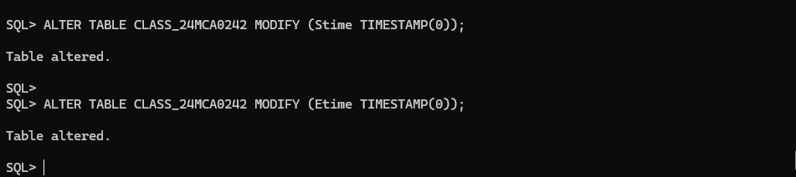

1. The Sem_code should start with either ‘Win’ or ‘Fall’ and Term column can assume only one of two values {Winter, Fall}.

ALTER TABLE SEMESTER_24MCA0242 ADD CONSTRAINT ck_sem_code CHECK (Sem_code LIKE 'Win%' OR Sem_code LIKE 'Fall%');

ALTER TABLE SEMESTER_24MCA0242 ADD CONSTRAINT ck_term CHECK (Term IN ('Winter', 'Fall'));

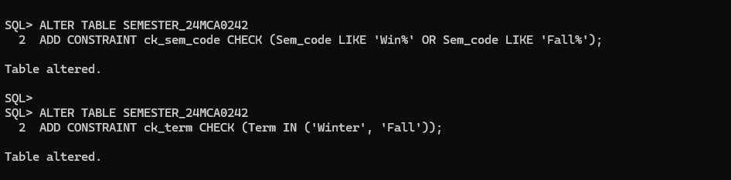

1. Email and mobile column in student table should have same characteristics as those in professor table.

ALTER TABLE STUDENT_24MCA0242 ADD CONSTRAINT uq_student_email UNIQUE (Email);

ALTER TABLE STUDENT_24MCA0242 ADD CONSTRAINT uq_student_mobile UNIQUE (Mobile);

ALTER TABLE STUDENT_24MCA0242 ADD CONSTRAINT ck_student_email CHECK (INSTR(Email, '@') > 1);

ALTER TABLE STUDENT_24MCA0242 ADD CONSTRAINT ck_student_mobile CHECK (LENGTH(Mobile) = 10);

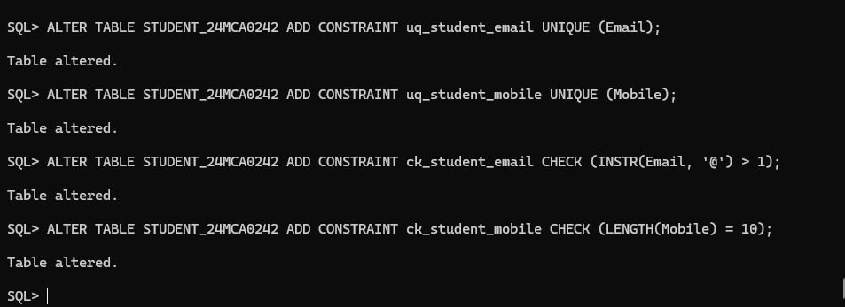

1. The enroll_time in the enroll table should be of timestamp data type without fractional parts of seconds. The grade may assume one of the values in {‘S’, ‘A’, ‘B’, ‘C’, ‘D’}

ALTER TABLE ENROLL_24MCA0242 MODIFY (Enroll_time TIMESTAMP(0));

ALTER TABLE ENROLL_24MCA0242 ADD CONSTRAINT ck_enroll_grade CHECK (Grade IN ('S', 'A', 'B', 'C', 'D'));

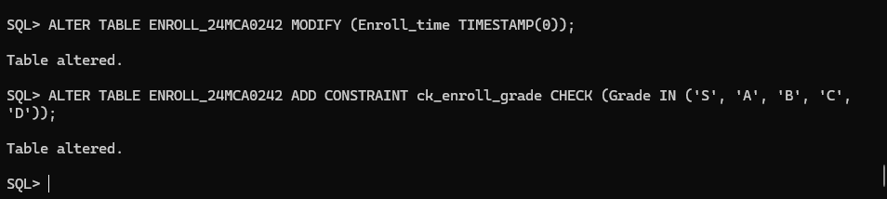

1. Use ‘on delete cascade’ or ‘on delete set null’ clause as requirements. Use deferrable constraint, if required.

ALTER TABLE DEPARTMENT_24MCA0242 ADD CONSTRAINT fk_dept_scode FOREIGN KEY (SCode) REFERENCES SCHOOL_24MCA0242(SCode) ON DELETE SET NULL DEFERRABLE;

ALTER TABLE PROFESSOR_24MCA0242 ADD CONSTRAINT fk_prof_dept FOREIGN KEY (Dept_id) REFERENCES DEPARTMENT_24MCA0242(Dept_id) ON DELETE CASCADE DEFERRABLE;

ALTER TABLE STUDENT_24MCA0242 ADD CONSTRAINT fk_student_dept FOREIGN KEY (Dept_id) REFERENCES DEPARTMENT_24MCA0242(Dept_id) ON DELETE SET NULL DEFERRABLE;

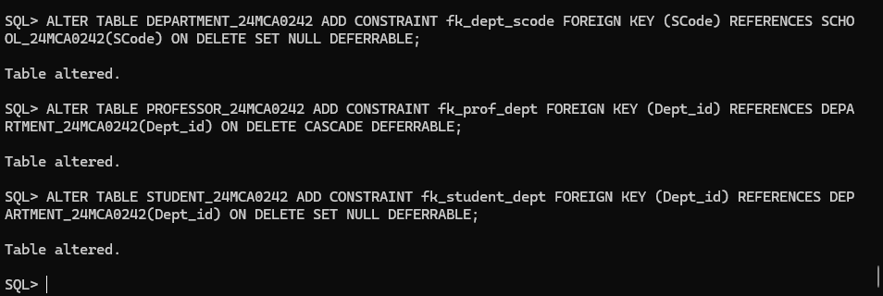

1. Additional (innovative) integrity constraints, if any, may be specified by you.

ALTER TABLE SEMESTER_24MCA0242 ADD CONSTRAINT CK_SEM_DATE CHECK (Sdate < Edate);

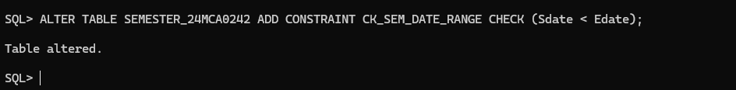

**4. In built functions**

1. Test the string manipulation functions – UPPER, LOWER, INITCAP, LENGTH, LPAD, RPAD, LTRIM, RTRIM and TRIM, using select queries on data present in the tables. Use one query each for demonstration of one function.
2. UPPER

SELECT UPPER(Prof_name) AS Uppercase_Prof_Name

FROM PROFESSOR_24MCA0242;

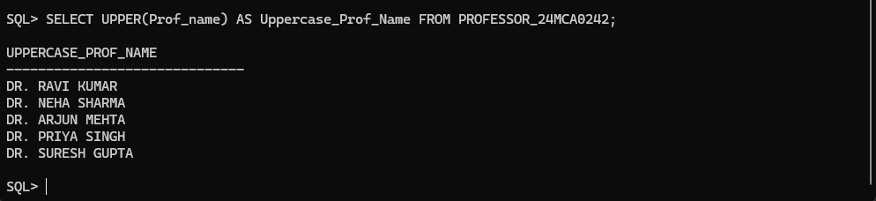

1. LOWER

SELECT LOWER(Email) AS Lowercase_Email FROM PROFESSOR_24MCA0242;

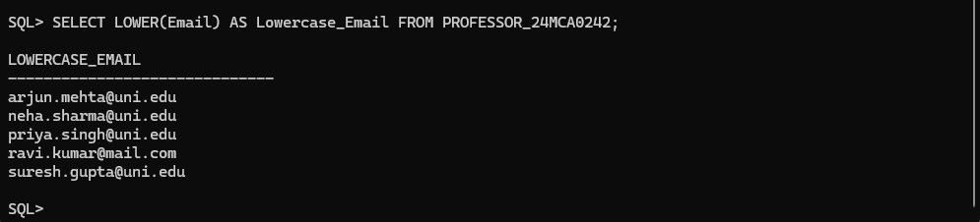

1. INITCAP

SELECT INITCAP(Speciality) AS Capitalized_Speciality

FROM PROFESSOR_24MCA0242;

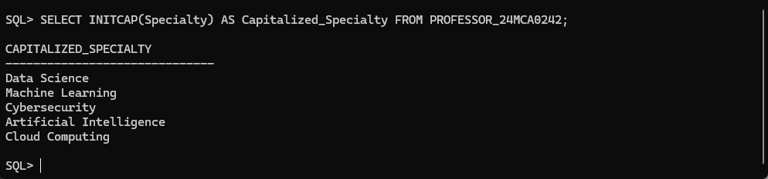

1. LENGTH

SELECT Prof_name, LENGTH(Prof_name) AS Name_Length

FROM PROFESSOR_24MCA0242;

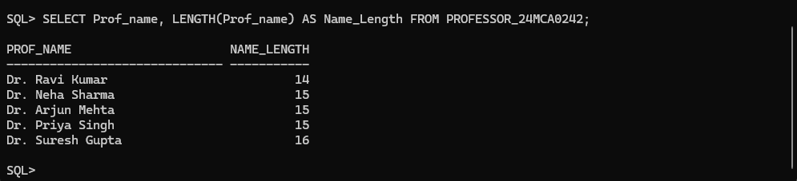

1. LPAD

SELECT Prof_id, LPAD(Prof_id, 10, 'PROF_') AS Padded_Prof_ID

FROM PROFESSOR_24MCA0242;

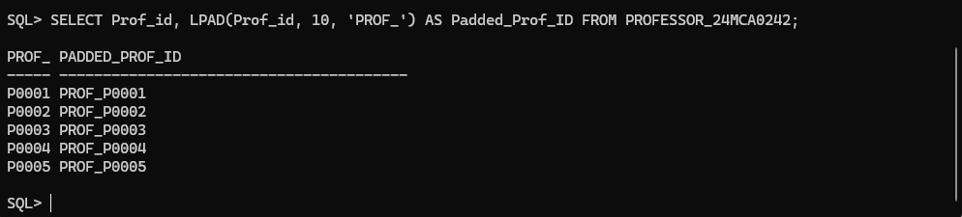

1. RPAD

SELECT Prof_id, RPAD(Prof_id, 10, '*') AS Padded_Prof_Name

FROM PROFESSOR_24MCA0242;

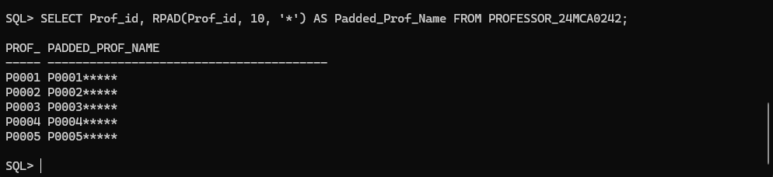

1. LTRIM

SELECT LTRIM(Prof_name, 'Dr. ') AS Trimmed_Prof_Name

FROM PROFESSOR_24MCA0242;

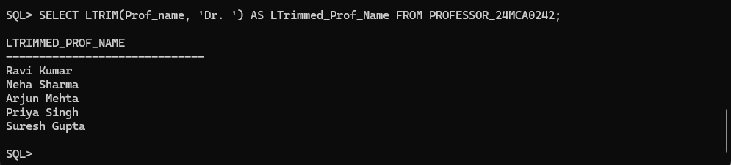

1. RTRIM

SELECT RTRIM(Prof_name, 'a') AS RTrimmed_Prof_Name

FROM PROFESSOR_24MCA0242;

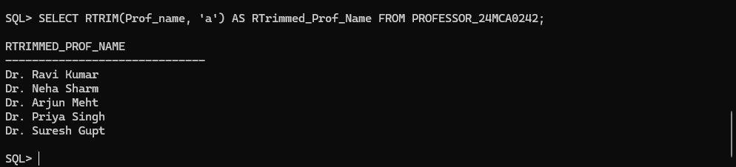

1. TRIM

SELECT TRIM( 'D' FROM Prof_name) AS Trimmed_Prof_Name

FROM PROFESSOR_24MCA0242;

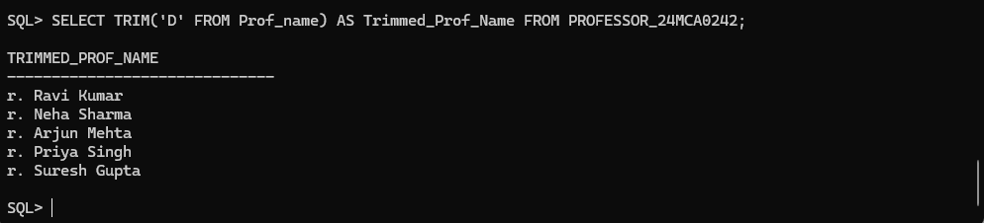

1. Write query to illustrate usage of NVL function and NULLIF function.
2. NVL

SELECT SCode, NVL(Location, 'No Location Provided') AS Location FROM SCHOOL_24MCA0242;

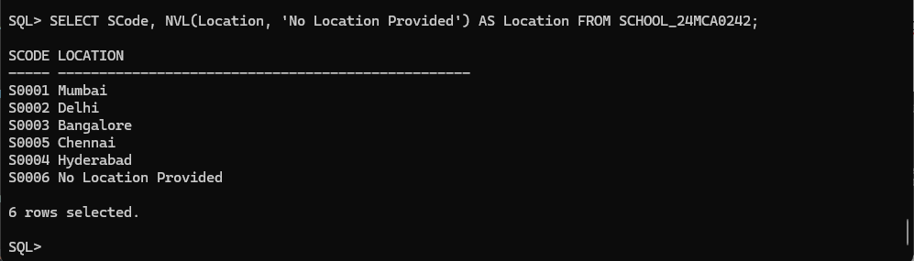

1. NULLIF

SELECT SCode, NULLIF(Location, 'No Location Provided') AS Location FROM SCHOOL_24MCA0242;

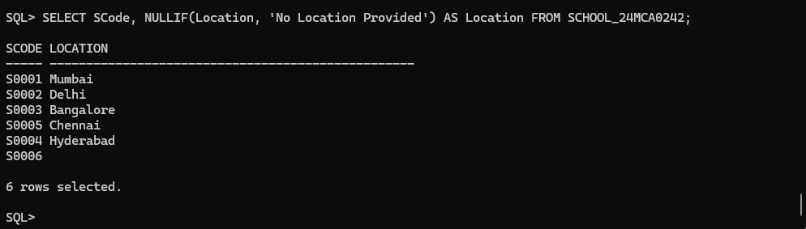

1. Display the name of the students who were born on a specified month.

SELECT Sname FROM STUDENT_24MCA0242 WHERE EXTRACT(MONTH FROM DOB) = 2;

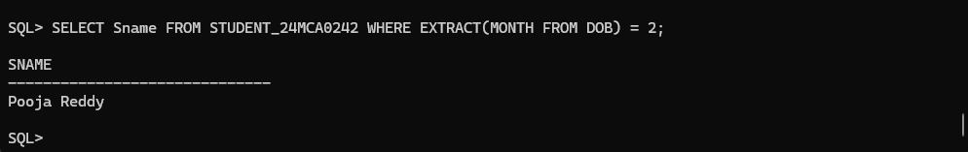

1. Display the name of the students with a specified date of birth.

SELECT Sname FROM STUDENT_24MCA0242 WHERE DOB = TO_DATE('1998-05-12', 'YYYY-MM-DD');

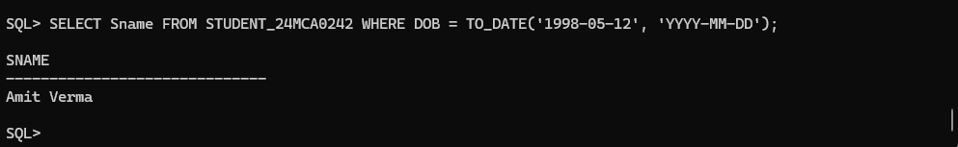

1. Display the date of birth of a specified student in the format ‘Day of week, Month dd, yyyy’.

SELECT Sname, TO_CHAR(DoB, 'Day, Month dd, yyyy') AS Formatted_DoB FROM STUDENT_24MCA0242 WHERE Reg_no = 'R0003';

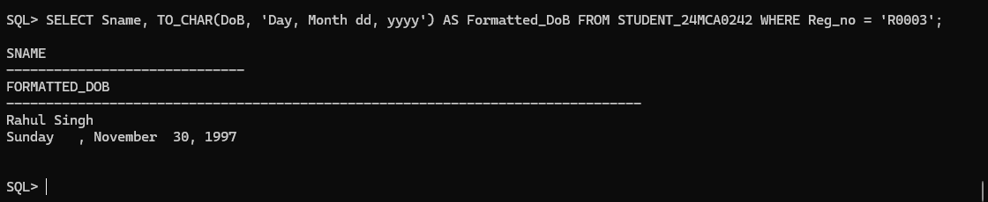

1. Display the hour and minutes of the start time and end time of a specified slot.

SELECT Cls_code, TO_CHAR(Stime, 'HH24:MI') AS S_Hr_Min, TO_CHAR(Etime, 'HH24:MI') AS E_Hr_Min FROM CLASS_24MCA0242 WHERE Cls_code = 'CLS01';

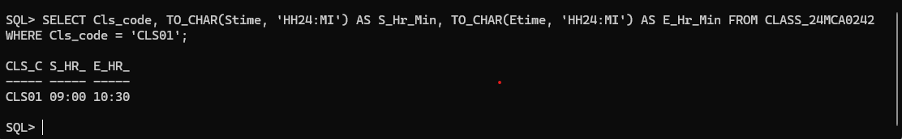

1. Display the day of week of the start date and end date of Winter semester 17–18.

SELECT Sem_code, TO_CHAR (Sdate, 'Day') AS Start_Day_of_Week, TO_CHAR (Edate, 'Day') AS End_Day_of_Week FROM SEMESTER_24MCA0242 WHERE Sem_code = 'Win2017';

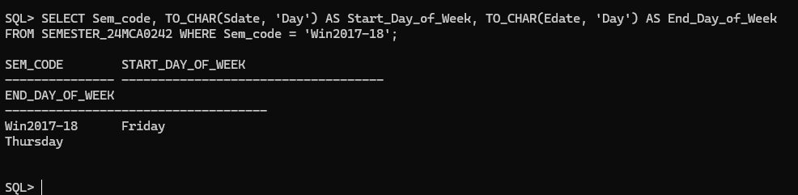

1. Display the duration of Winter semester 17–18 in terms of number of weeks.

SELECT Sem_code, ROUND((Edate - Sdate) / 7, 2) AS Duration_in_Weeks FROM SEMESTER_24MCA0242 WHERE Sem_code = 'Win2017-18';

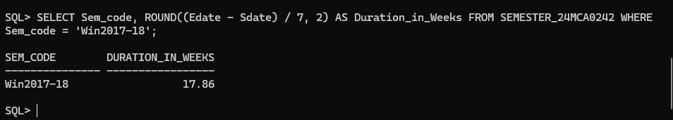

1. Store date in the format dd/mm/yy for DOB of newly admitted student.

INSERT INTO STUDENT_24MCA0242 (Reg_no, Sname, Address, DoB, Email, Mobile, Dept_id, Prof_id) VALUES ('R0007', 'Samay Raina', 'Pune', TO_DATE('2003-05-12', 'YYYY-MM-DD'), 'samay.raina@student.edu', '9876543888', 'D0002', 'P0002');

SELECT Sname, TO_CHAR(DOB, 'DD/MM/YY') AS Formatted_DoB FROM STUDENT_24MCA0242 WHERE Reg_no = 'R0007';

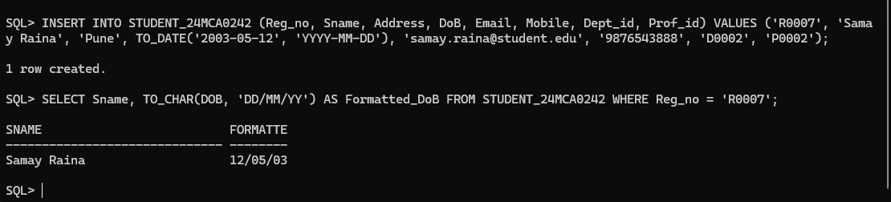

1. Test the numeric functions – CEIL, FLOOR, TRUCATE, MIN, MAX, AVG,COUNT using select queries on data present in the tables. Use one query each for demonstration of one function.
2. CEIL

SELECT AVG(Credits) AS Avg_Credits, CEIL(AVG(Credits)) AS Ceil_Avg_Credits FROM COURSE_24MCA0242;

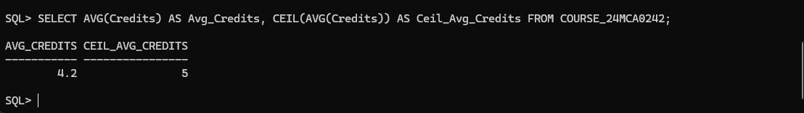

1. FLOOR

SELECT AVG(Credits) AS Avg_Credits, FLOOR(AVG(Credits)) AS Floor_Avg_Credits FROM COURSE_24MCA0242;

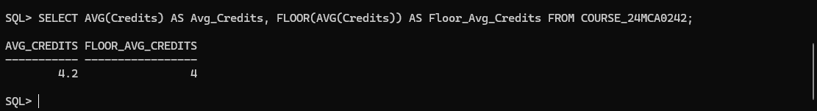

1. TRUNCATE

SELECT TRUNC(AVG(Credits)) AS Truncated_Avg_Credits FROM COURSE_24MCA0242;

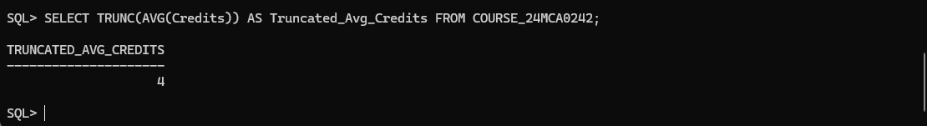

1. MIN

SELECT MIN(Credits) AS Min_Credits FROM COURSE_24MCA0242;

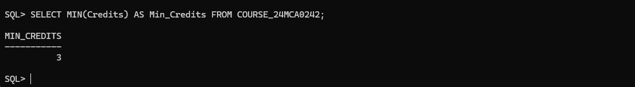

1. MAX

SELECT MAX(Credits) AS Max_Credits FROM COURSE_24MCA0242;

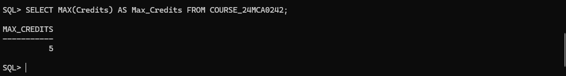

1. AVG

SELECT AVG(Credits) AS Avg_Credits FROM COURSE_24MCA0242;

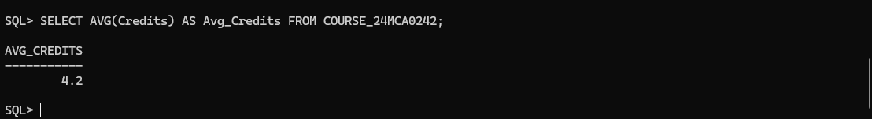

1. COUNT

SELECT COUNT(*) AS Total_Students FROM STUDENT_24MCA0242;

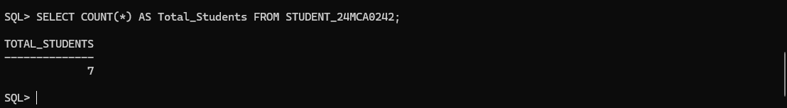

**5. Write queries for**

1. Display name, email address and address for those students who live in Katpadi area and whose name has an l as the third character.

SELECT Sname, Email, Address FROM STUDENT_24MCA0242 WHERE Address = 'Katpadi' AND Sname LIKE '__l%';

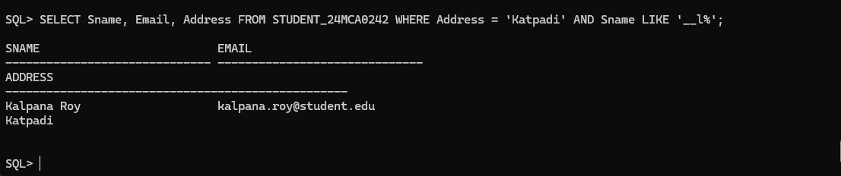

1. Display name, email address and address for those students who are not from Tamil Nadu.

SELECT Sname, Email, Address FROM STUDENT_24MCA0242 WHERE Address NOT IN('Tamil Nadu');

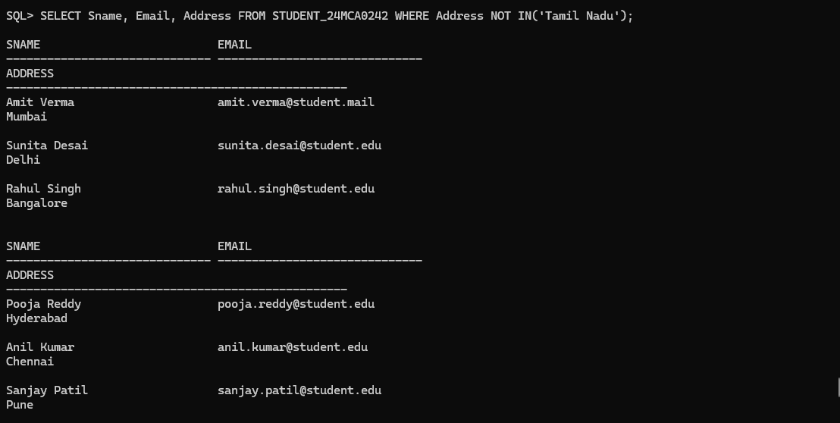

1. Display name, email address and address of foreign students only.

SELECT Sname, Email, Address FROM STUDENT_24MCA0242 WHERE Address NOT LIKE '%India';

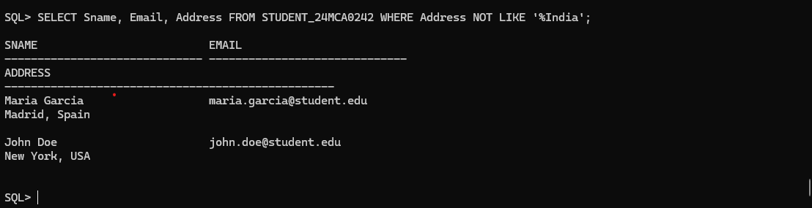

1. List the name of professors along with their specialty who belong to School of Medicine.

SELECT P.Prof_name, P.Specialty, S.Scl_name FROM PROFESSOR_24MCA0242 P JOIN DEPARTMENT_24MCA0242 D ON P.Dept_id = D.Dept_id JOIN SCHOOL_24MCA0242 S ON D.Scode = S.Scode WHERE S.Scl_name = 'School of Medicine';

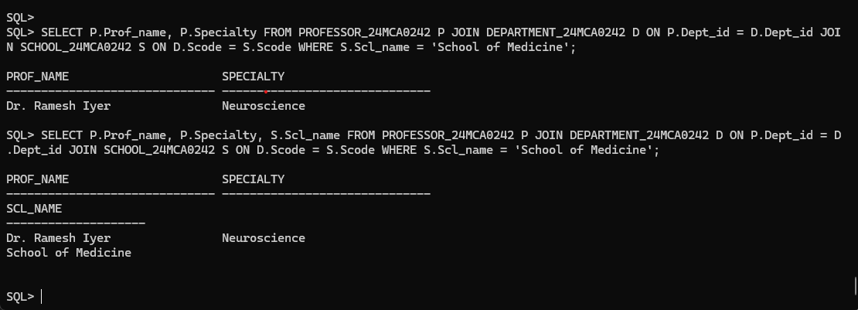

1. Display name of the school and name of professor who chairs the school.

SELECT Scl_name, Prof_name FROM SCHOOL_24MCA0242, PROFESSOR_24MCA0242 WHERE SCHOOL_24MCA0242.Prof_id = PROFESSOR_24MCA0242.Prof_id;

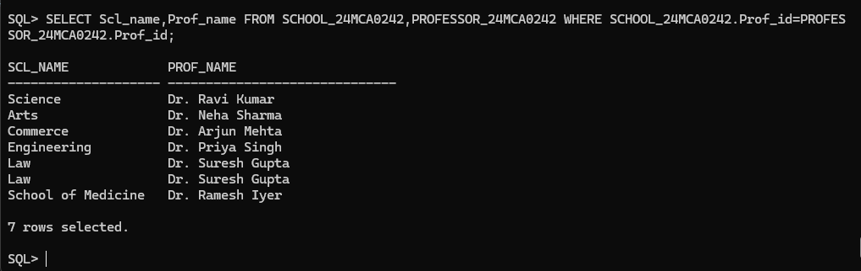

1. List course code, course name and course description in alphabetic order of course code.

SELECT Crs_code, Crs_name, Description FROM COURSE_24MCA0242 ORDER BY Crs_code;

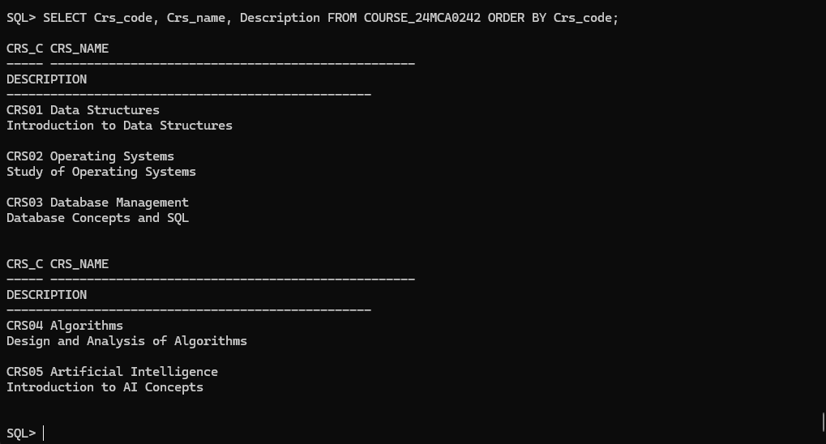

1. Change the mobile number of a student interactively.

UPDATE STUDENT_24MCA0242 SET Mobile = &Mobile WHERE Reg_no = '&Reg_no';

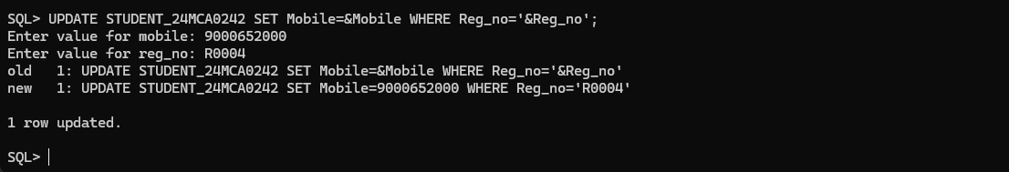

1. Remove enrollment information of a student from a particular course interactively. How would you recover the data?

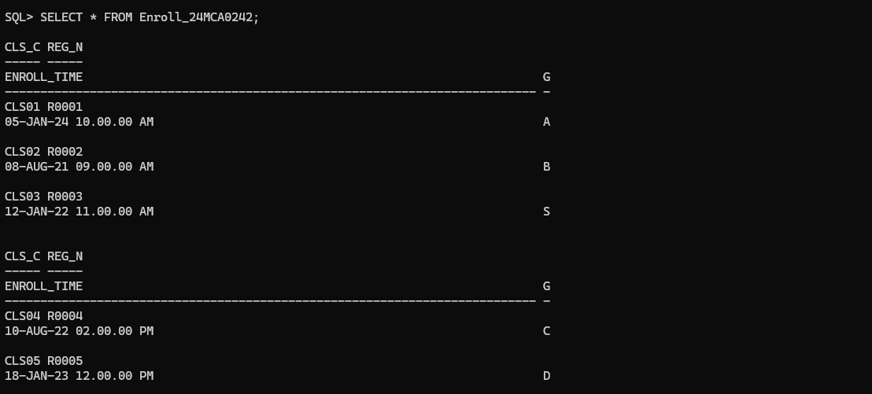

DELETE FROM ENROLL_24MCA0242 WHERE Cls_code = '&Cls_code' AND Reg_no = '&Reg_no';

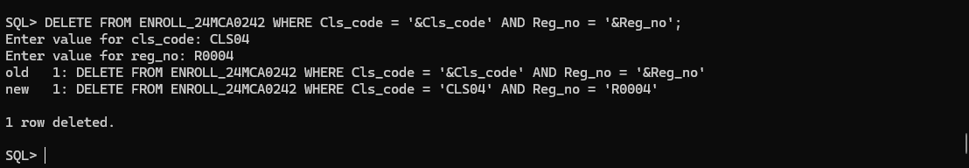

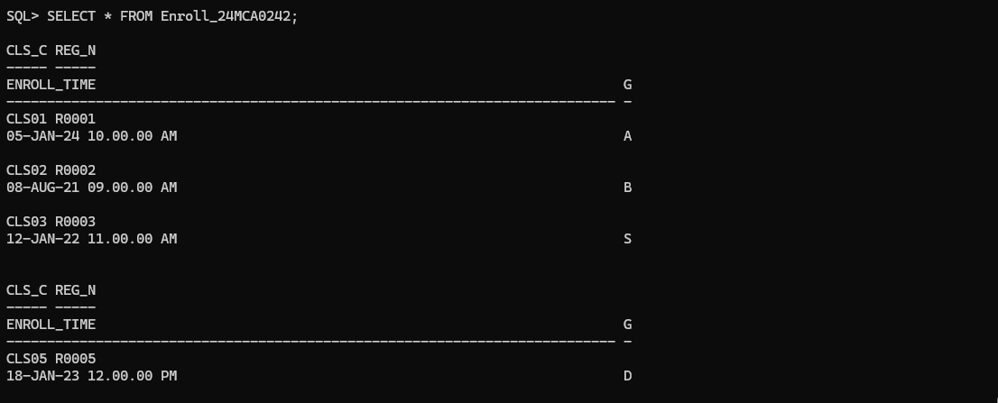

ROLLBACK;





1. Create a duplicate of course table.

CREATE TABLE COURSE_DUPLICATE AS SELECT * FROM COURSE_24MCA0242;

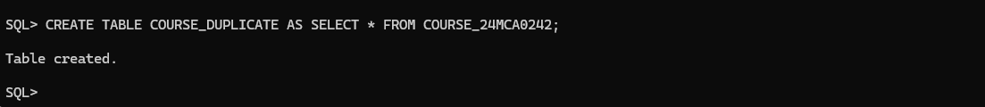

1. Create a view for list of students (Reg_no, Sname) and the courses they have registered along with name of professors teaching the course.

CREATE VIEW Student_Course_Professor_View AS SELECT s.Reg_no, s.Sname, c.Crs_code, c.Crs_name, p.Prof_name FROM STUDENT_24MCA0242 s JOIN ENROLL_24MCA0242 e ON s.Reg_no = e.Reg_no JOIN CLASS_24MCA0242 cl ON e.Cls_code = cl.Cls_code JOIN COURSE_24MCA0242 c ON cl.Crs_code = c.Crs_code JOIN PROFESSOR_24MCA0242 p ON cl.Prof_id = p.Prof_id;

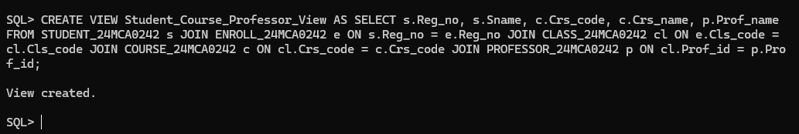

SELECT * FROM Student_Course_Professor_View;

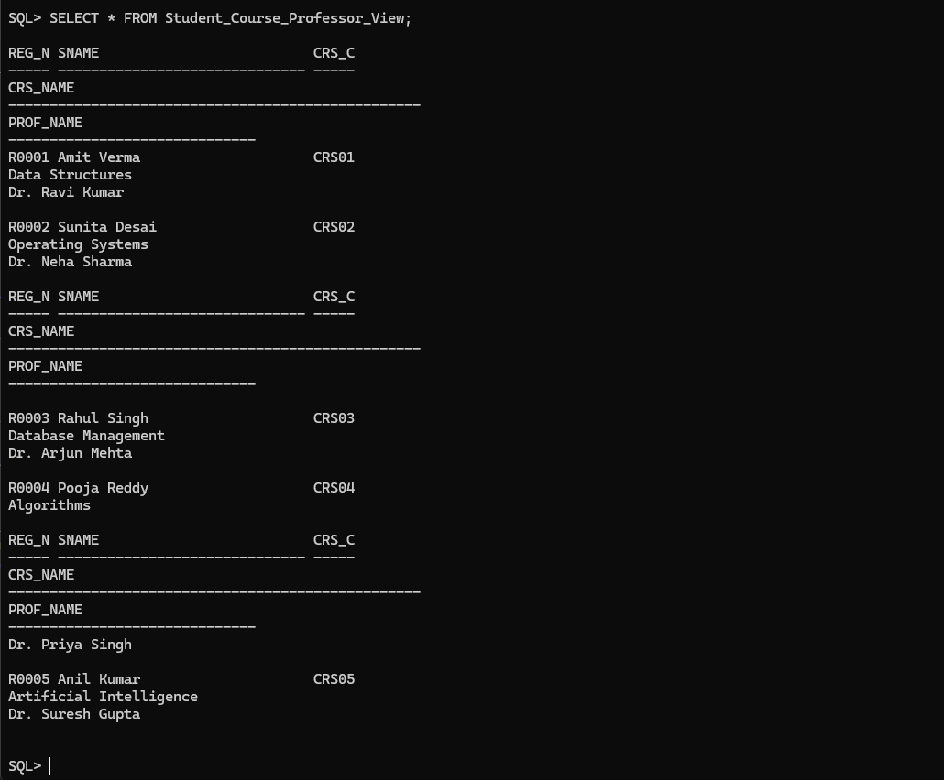

1. List the room number, slot, start time, end time and duration of every class held on Wednesdays in descending order of room number.

SELECT Room_no, Slot, Stime, Etime,

EXTRACT(HOUR FROM (Etime - Stime)) || ':' ||

EXTRACT(MINUTE FROM (Etime - Stime)) AS Duration

FROM CLASS_24MCA0242 WHERE Day_of_week = 'Wednesday' ORDER BY Room_no DESC;

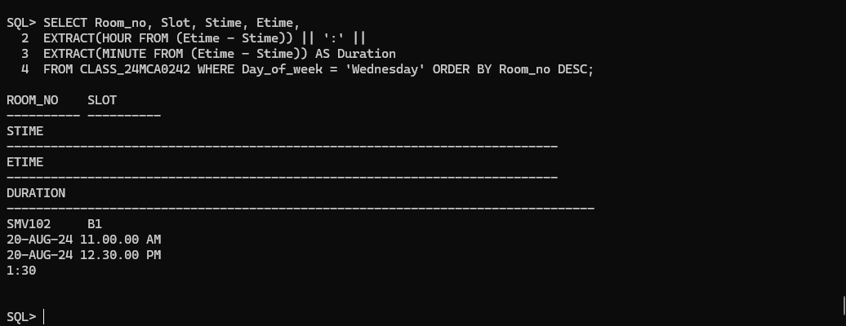

1. Display the name and grade of a student in different courses underwent in fall semester 2017 – 18.

SELECT s.Sname, e.Grade, c.Crs_name FROM STUDENT_24MCA0242 s

JOIN ENROLL_24MCA0242 e ON s.Reg_no = e.Reg_no

JOIN CLASS_24MCA0242 cl ON e.Cls_code = cl.Cls_code

JOIN COURSE_24MCA0242 c ON cl.Crs_code = c.Crs_code

JOIN SEMESTER_24MCA0242 sem ON cl.Sem_code = sem.Sem_code

WHERE sem.Sem_code = 'Fall2017-18';

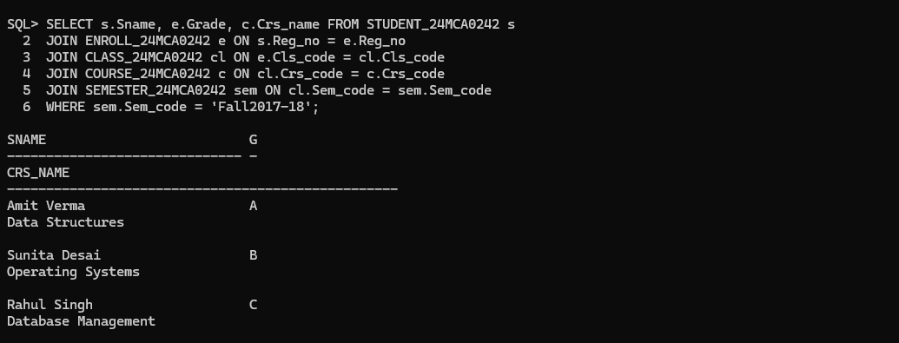

1. Find out name of students who have taken Database Systems course as well as Operating Systems course in fall semester 2016 – 17.

SELECT s.Sname FROM STUDENT_24MCA0242 s

JOIN ENROLL_24MCA0242 e ON s.Reg_no = e.Reg_no

JOIN CLASS_24MCA0242 c ON e.Cls_code = c.Cls_code

JOIN COURSE_24MCA0242 cr ON c.Crs_code = cr.Crs_code

JOIN SEMESTER_24MCA0242 sem ON c.Sem_code = sem.Sem_code

WHERE sem.Term = 'Fall' AND sem.Year = 2016 AND cr.Crs_name IN ('Database Systems', 'Operating Systems') GROUP BY s.Sname;

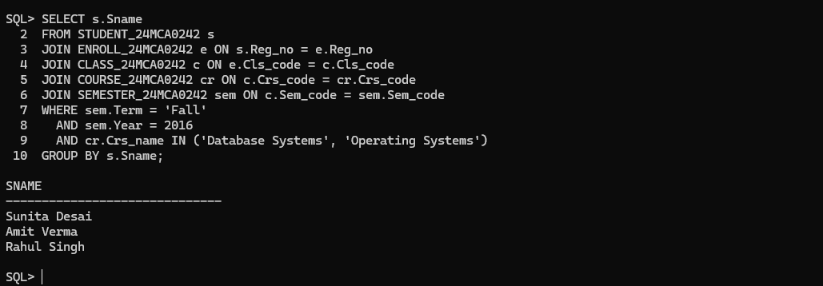

1. Find out name of students who have taken Database Systems course but have not taken Operating Systems course in winter semester 2017 – 18.

SELECT s.SNAME FROM STUDENT_24MCA0242 s

JOIN ENROLL_24MCA0242 e ON s.REG_No = e.REG_No

JOIN CLASS_24MCA0242 c ON e.CLS_Code = c.CLS_Code

JOIN COURSE_24MCA0242 cr ON c.CRS_Code = cr.CRS_Code

WHERE c.SEM_CODE = 'Win2017-18' AND cr.CRS_NAME = 'Database Systems' AND s.REG_No NOT IN (

SELECT e.REG_No FROM ENROLL_24MCA0242 e

JOIN CLASS_24MCA0242 c ON e.CLS_Code = c.CLS_Code

JOIN COURSE_24MCA0242 cr ON c.CRS_Code = cr.CRS_Code

WHERE c.SEM_CODE = 'Win2017-18' AND cr.CRS_NAME = 'Operating Systems');

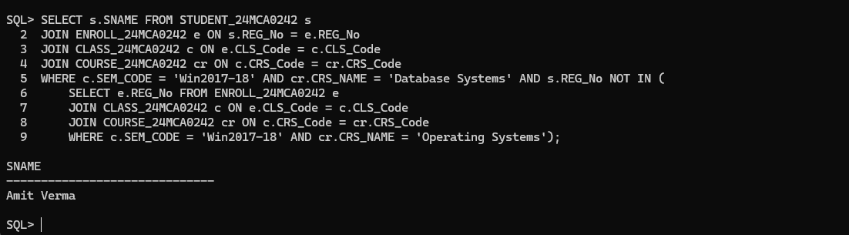

1. List the registration number and name of the students who have registered for maximum number of credits in Winter 17-18 semester.

SELECT s.REG_No, s.SNAME, SUM(cr.Credits) AS TotalCredits

FROM STUDENT_24MCA0242 s

JOIN ENROLL_24MCA0242 e ON s.REG_No = e.REG_No

JOIN CLASS_24MCA0242 c ON e.CLS_Code = c.CLS_Code

JOIN COURSE_24MCA0242 cr ON c.CRS_Code = cr.CRS_Code

WHERE c.SEM_CODE = 'Win2017-18'

GROUP BY s.REG_No, s.SNAME

HAVING SUM(cr.Credits) = (

SELECT MAX(TotalCredits)

FROM (

SELECT SUM(cr.Credits) AS TotalCredits FROM STUDENT_24MCA0242 s

JOIN ENROLL_24MCA0242 e ON s.REG_No = e.REG_No

JOIN CLASS_24MCA0242 c ON e.CLS_Code = c.CLS_Code

JOIN COURSE_24MCA0242 cr ON c.CRS_Code = cr.CRS_Code

WHERE c.SEM_CODE = 'Win2017-18' GROUP BY s.REG_No ));

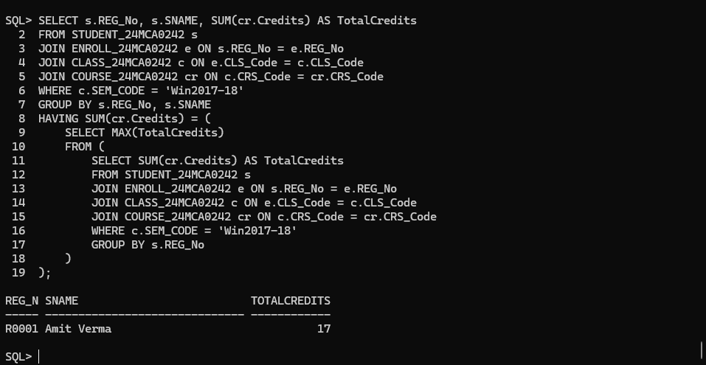

1. List the name of the course and the number of students registered in each slot for course under different faculty members.

SELECT cr.Crs_name AS CourseName, c.Slot AS Slot, p.Prof_name AS FacultyName, COUNT(e.Reg_no) AS NumberOfStudents FROM COURSE_24MCA0242 cr

JOIN CLASS_24MCA0242 c ON cr.Crs_code = c.Crs_code

JOIN ENROLL_24MCA0242 e ON c.Cls_code = e.Cls_code

JOIN PROFESSOR_24MCA0242 p ON c.Prof_id = p.Prof_id

GROUP BY cr.Crs_name, c.Slot, p.Prof_name ORDER BY cr.Crs_name, c.Slot, p.Prof_name;

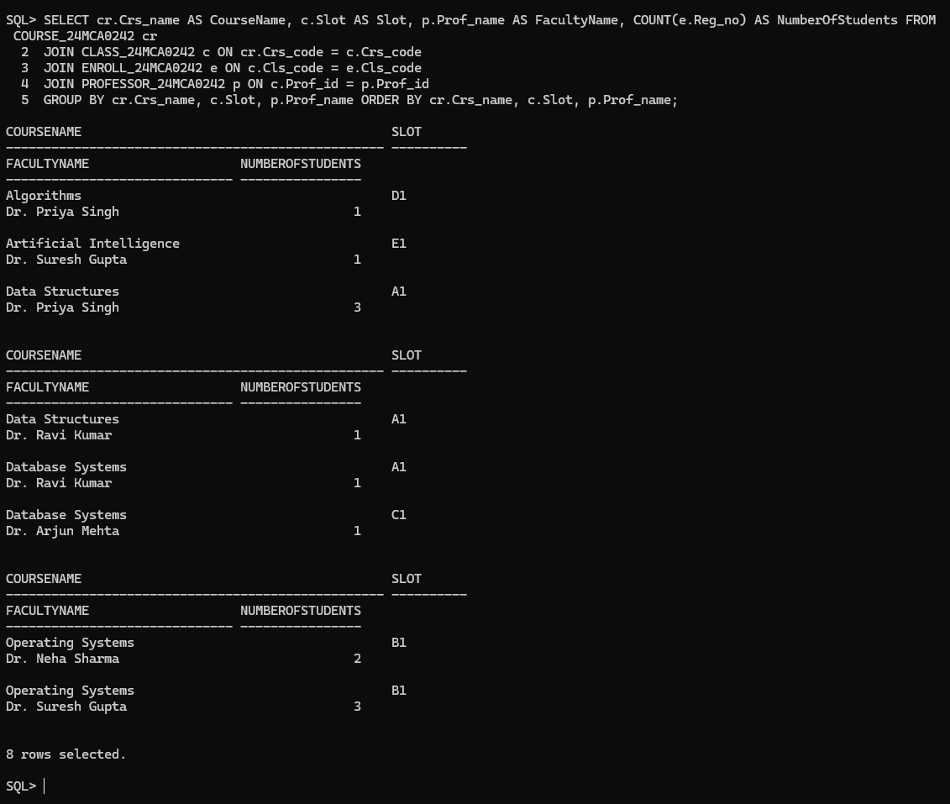

1. Find out the name of the students who have registered in all the courses being taught by Prof. O’Brien in Winter 17-18.

SELECT s.Sname FROM STUDENT_24MCA0242 s

JOIN ENROLL_24MCA0242 e ON s.REG_No = e.REG_No

JOIN CLASS_24MCA0242 c ON e.CLS_Code = c.CLS_Code

WHERE c.Crs_code IN (

SELECT c2.Crs_code FROM CLASS_24MCA0242 c2

JOIN PROFESSOR_24MCA0242 p ON c2.Prof_id = p.Prof_id

WHERE p.Prof_name = 'Prof. O''Brien' AND c2.SEM_CODE = 'Win2017-18')

GROUP BY s.Sname HAVING COUNT(DISTINCT c.Crs_code) = (

SELECT COUNT(*) FROM CLASS_24MCA0242 c2

JOIN PROFESSOR_24MCA0242 p ON c2.Prof_id = p.Prof_id

WHERE p.Prof_name = 'Prof. O''Brien' AND c2.SEM_CODE = 'Win2017-18');

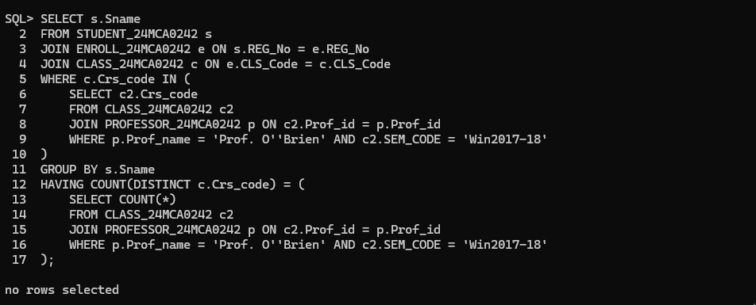

1. List the registration number of the students who registered in Database Systems course on November 17, 2017.

SELECT e.Reg_no, s.Sname, cr.Crs_name FROM ENROLL_24MCA0242 e

JOIN CLASS_24MCA0242 c ON e.CLS_Code = c.CLS_Code

JOIN COURSE_24MCA0242 cr ON c.CRS_Code = cr.CRS_Code

JOIN STUDENT_24MCA0242 s ON e.Reg_no = s.Reg_no

WHERE cr.Crs_name = 'Database Systems' AND TRUNC(e.Enroll_time) = TO_DATE('2017-11-17', 'YYYY-MM-DD');

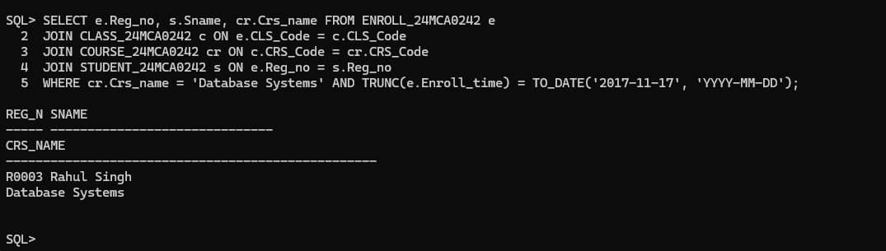

1. Write a query to display the grade of a student given his/her registration number and the course name for Fall semester 17–18.

SELECT e.Reg_no, s.Sname, cr.Crs_name, e.Grade FROM ENROLL_24MCA0242 e

JOIN CLASS_24MCA0242 c ON e.Cls_code = c.Cls_code

JOIN COURSE_24MCA0242 cr ON c.Crs_code = cr.Crs_code

JOIN STUDENT_24MCA0242 s ON e.Reg_no = s.Reg_no

JOIN SEMESTER_24MCA0242 sem ON c.Sem_code = sem.Sem_code

WHERE s.Reg_no = 'R0005' AND cr.Crs_name = 'Artificial Intelligence' AND sem.Sem_code = 'Fall2024-25';

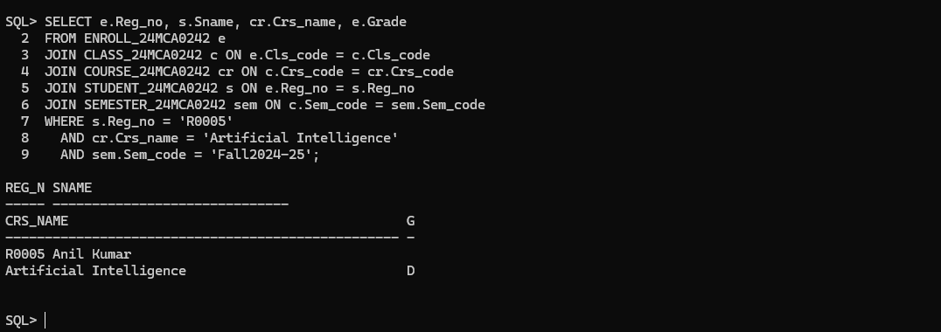

1. List the name of departments and the name professors who is in charge of the department.

SELECT d.Dname AS Department_Name, p.Prof_name AS Professor_Name FROM DEPARTMENT_24MCA0242 d JOIN PROFESSOR_24MCA0242 p ON d.Prof_id = p.Prof_id;

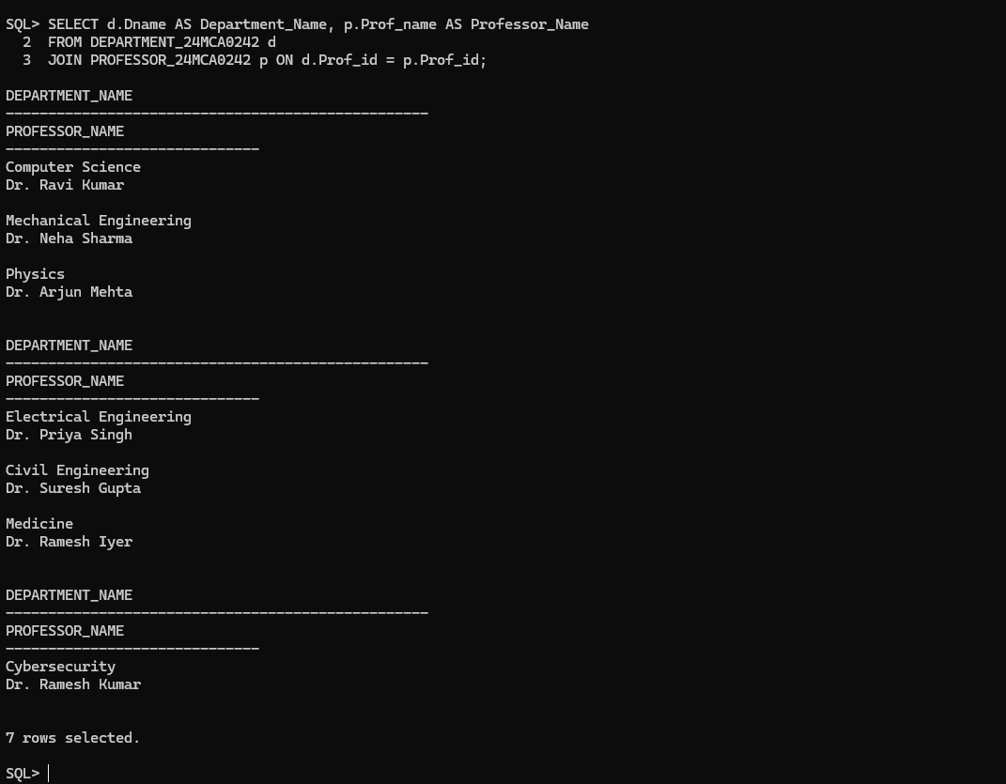

1. List the name of schools with students’ strength higher than 7000.

SELECT s.Scl_name AS School_Name FROM SCHOOL_24MCA0242 s

JOIN STUDENT_24MCA0242 st ON s.Prof_id = st.Prof_id

GROUP BY s.Scl_name HAVING COUNT(st.Reg_no) > 7000;

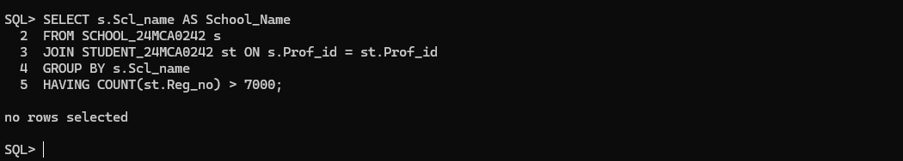

1. List the name of the department(s) under school of medicine with student strength higher than the average students of all the departments in the school.

SELECT sc.Scl_name, d.Dname FROM DEPARTMENT_24MCA0242 d

JOIN SCHOOL_24MCA0242 sc ON d.SCode = sc.SCode

JOIN STUDENT_24MCA0242 s ON d.Dept_id = s.Dept_id

WHERE sc.Scl_name = 'School of Medicine' GROUP BY sc.Scl_name, d.Dname

HAVING COUNT(s.Reg_no) > (

SELECT AVG(Student_Count) FROM (

SELECT d.Dept_id, COUNT(s.Reg_no) AS Student_Count

FROM DEPARTMENT_24MCA0242 d

JOIN SCHOOL_24MCA0242 sc ON d.SCode = sc.SCode

JOIN STUDENT_24MCA0242 s ON d.Dept_id = s.Dept_id

WHERE sc.Scl_name = 'School of Medicine' GROUP BY d.Dept_id

) dept_counts );

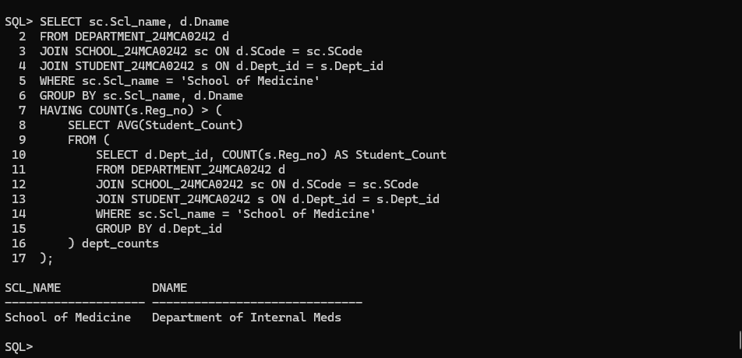

1. Given the registration number of a student, display the total credits registered by him/her in Winter 17–18.

SELECT e.Reg_no, SUM(cr.Credits) AS Total_Credits FROM ENROLL_24MCA0242 e

JOIN CLASS_24MCA0242 c ON e.Cls_code = c.Cls_code

JOIN COURSE_24MCA0242 cr ON c.Crs_code = cr.Crs_code

JOIN SEMESTER_24MCA0242 s ON c.Sem_code = s.Sem_code

WHERE e.Reg_no = 'R0001' AND s.Term = 'Winter' AND s.Year = 2017 GROUP BY e.Reg_no;

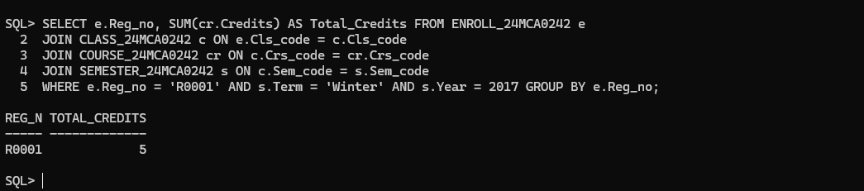

1. Given the registration number of a student, display her/his grade in the course she/he registered in Fall 17–18.

SELECT e.Reg_no, e.Grade, c.Crs_code, s.Term AS Semester, s.Year AS Academic_Year FROM ENROLL_24MCA0242 e

JOIN CLASS_24MCA0242 c ON e.Cls_code = c.Cls_code

JOIN SEMESTER_24MCA0242 s ON c.Sem_code = s.Sem_code

WHERE s.Term = 'Fall' AND s.Year = 2017 AND e.Reg_no = 'R0003';

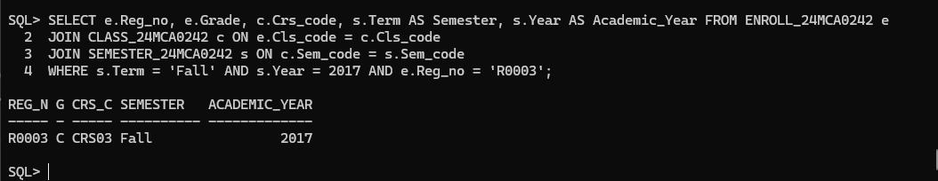

1. Display the name of the courses that are not being offered in Winter 17–18.

SELECT DISTINCT cr.Crs_name

FROM COURSE_24MCA0242 cr

LEFT JOIN CLASS_24MCA0242 c ON cr.Crs_code = c.Crs_code

LEFT JOIN SEMESTER_24MCA0242 s ON c.Sem_code = s.Sem_code

WHERE s.Term IS NULL OR s.Term <> 'Winter' OR s.Year <> 2017;

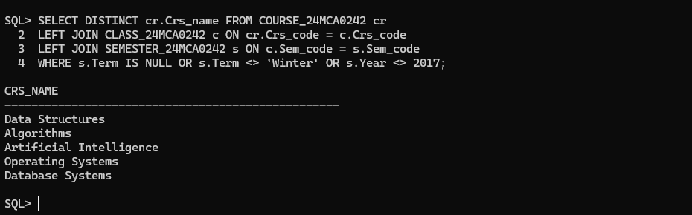

1. Write necessary SQL statement to advance the start time and end time of every class by ten minutes in Fall 17-18.

UPDATE CLASS_24MCA0242 SET Stime = Stime + INTERVAL '10' MINUTE, Etime = Etime + INTERVAL '10' MINUTE

WHERE Sem_code = (SELECT Sem_code FROM SEMESTER_24MCA0242 WHERE Term = 'Fall' AND Year = 2017);

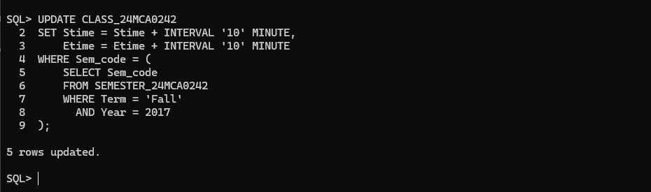

1. Write necessary SQL statement to advance the start date and end date of Fall 24–25 semester by one week with respect to Fall semester of 23 – 24.

UPDATE SEMESTER_24MCA0242

SET Sdate = (SELECT Sdate + INTERVAL '7' DAY FROM SEMESTER_24MCA0242 WHERE Term = 'Fall' AND Year = 2023),

Edate = (SELECT Edate + INTERVAL '7' DAY FROM SEMESTER_24MCA0242 WHERE Term = 'Fall' AND Year = 2023)

WHERE Term = 'Fall' AND Year = 2024;

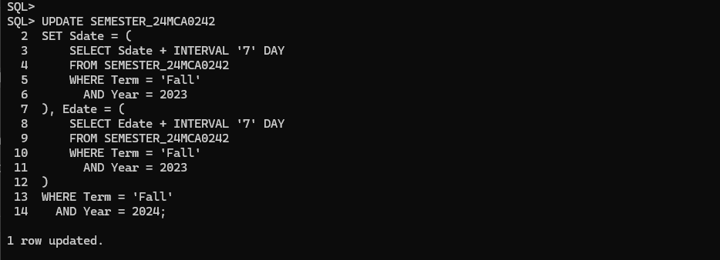

SELECT Sem_code, Term, Year, Sdate, Edate FROM SEMESTER_24MCA0242 WHERE Term = 'Fall' AND Year = 2024;

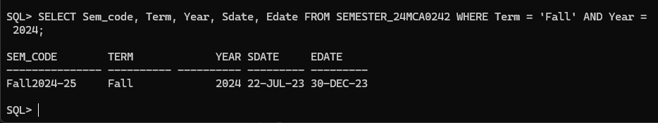

1. Find out the name list of students who had secured ‘S’ grade in at least 50% of the courses cleared by her/him.

SELECT s.Sname FROM STUDENT_24MCA0242 s

JOIN ENROLL_24MCA0242 e ON s.Reg_no = e.Reg_no

GROUP BY s.Sname, s.Reg_no

HAVING COUNT(CASE WHEN e.Grade = 'S' THEN 1 END) * 100.0 / COUNT(e.Grade) >= 50;

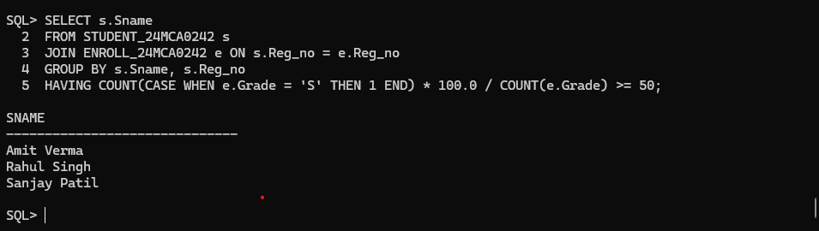

1. Given the registration number of a student, find out his/her free slots.

SELECT DISTINCT c.Slot, c.Day_of_week FROM CLASS_24MCA0242 c

LEFT JOIN ENROLL_24MCA0242 e ON c.Cls_code = e.Cls_code AND e.Reg_no = 'R0001' WHERE e.Cls_code IS NULL;

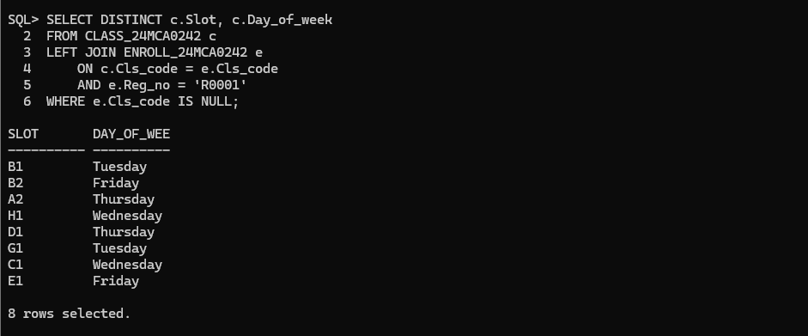

1. Find out the name list of students who have classes in the afternoon session only a specific day of the week.

SELECT s.Sname FROM STUDENT_24MCA0242 s

JOIN ENROLL_24MCA0242 e ON s.Reg_no = e.Reg_no

JOIN CLASS_24MCA0242 c ON e.Cls_code = c.Cls_code

WHERE c.Day_of_week = 'Monday' AND c.Stime >= TO_TIMESTAMP('12:00:00', 'HH24:MI:SS') GROUP BY s.Sname HAVING COUNT(DISTINCT c.Day_of_week) = 1 AND SUM(CASE WHEN c.Stime >= TO_TIMESTAMP('12:00:00', 'HH24:MI:SS') THEN 1 ELSE 0 END) = COUNT(c.Day_of_week);

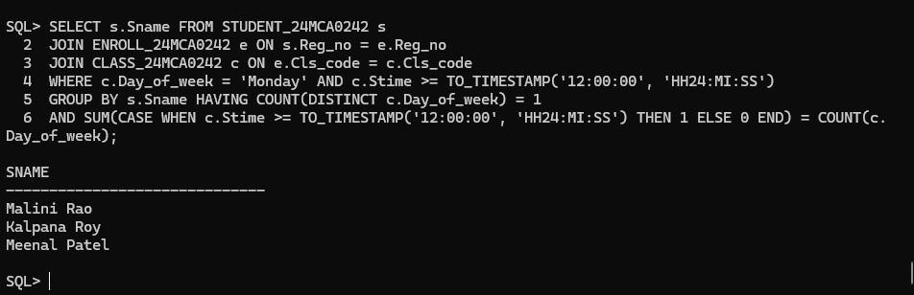

1. Add a column named ‘Duration’ (to indicate duration of a class) with appropriate data type to the CLASS table and populate the column from values of start time and end time columns.

ALTER TABLE CLASS_24MCA0242 ADD Duration INTERVAL DAY(0) TO SECOND(0);

UPDATE CLASS_24MCA0242 SET Duration = Etime - Stime;

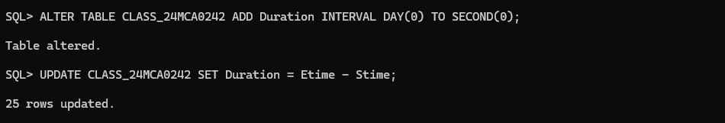

SELECT Cls_code, Slot, Stime, Etime, Duration FROM CLASS_24MCA0242;

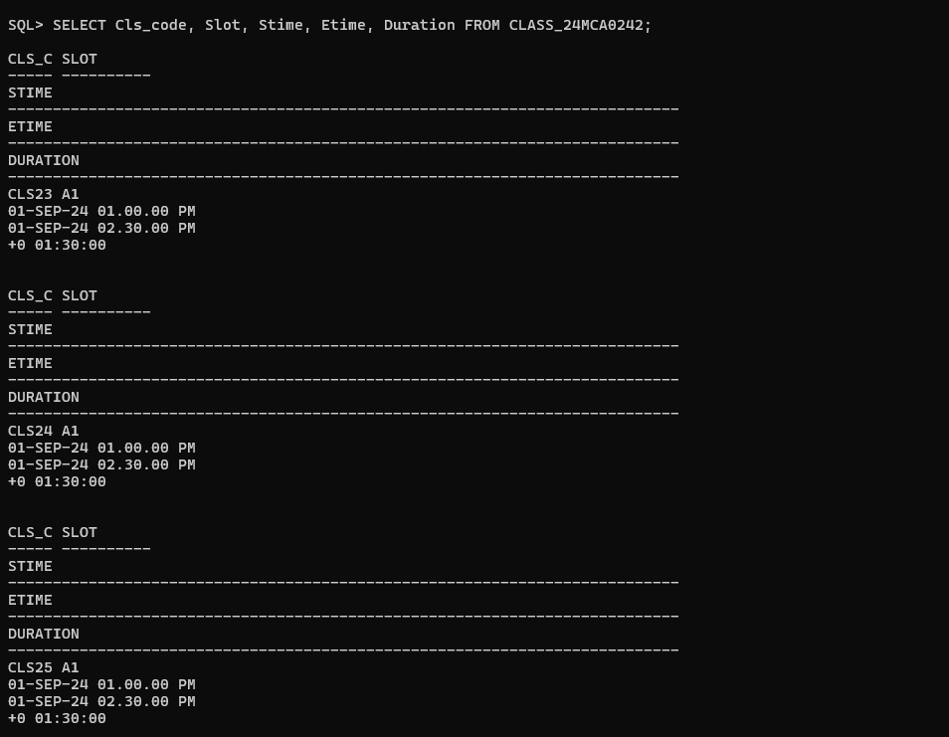

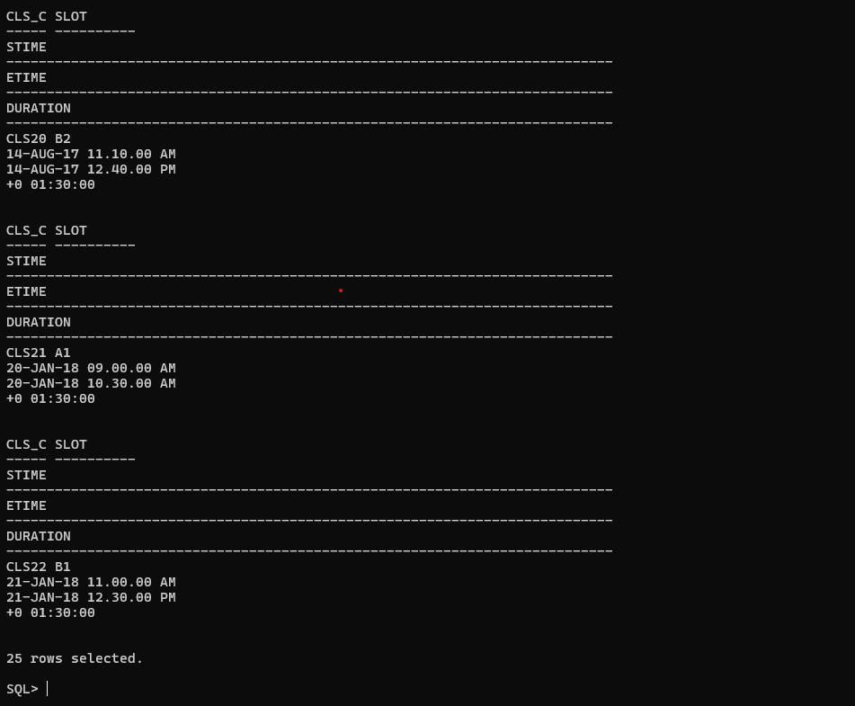

1. Add a column named ‘SemesterDuration’ (indicating duration of a semester) with appropriate data type to the SEMESTER table and populate the column from values of start date and end date columns.

ALTER TABLE SEMESTER_24MCA0242 ADD SemesterDuration NUMBER;

UPDATE SEMESTER_24MCA0242 SET SemesterDuration = Edate - Sdate;

SELECT Sem_code, Term, Year, Sdate, Edate, SemesterDuration FROM SEMESTER_24MCA0242;

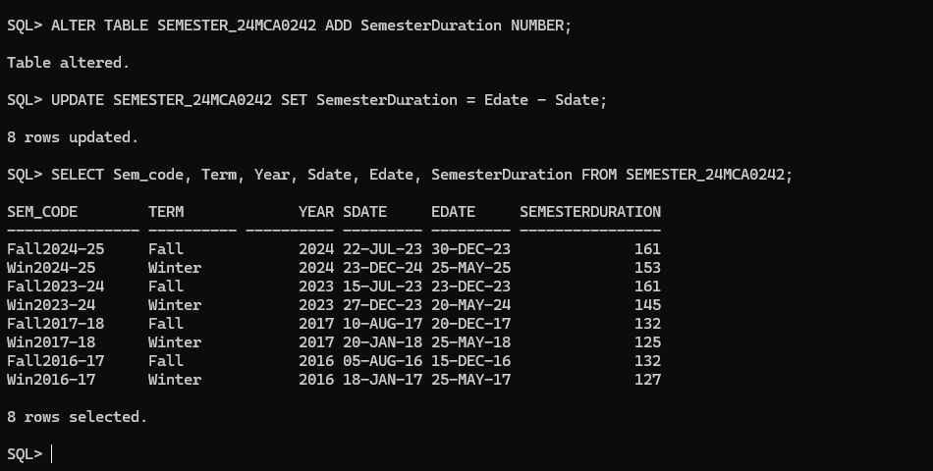

1. Find out the list of students who are undergoing MCA program.

SELECT s.Reg_no, s.Sname, p.Prog_name FROM STUDENT_24MCA0242 s

JOIN PROGRAMME_24MCA0242 p ON s.Dept_id = p.Dept_id WHERE p.Prog_name = 'MCA';

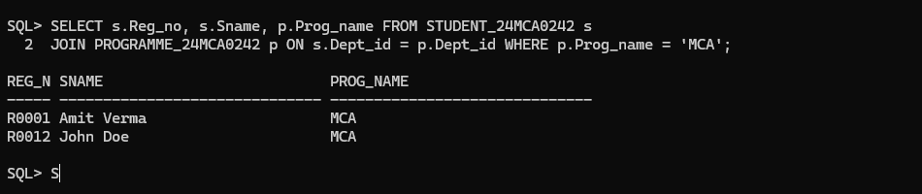

1. Display the name of programs and the name of school offering the program.

SELECT p.Prog_name, s.Scl_name FROM PROGRAMME_24MCA0242 p

JOIN DEPARTMENT_24MCA0242 d ON p.Dept_id = d.Dept_id

JOIN SCHOOL_24MCA0242 s ON d.SCode = s.SCode;

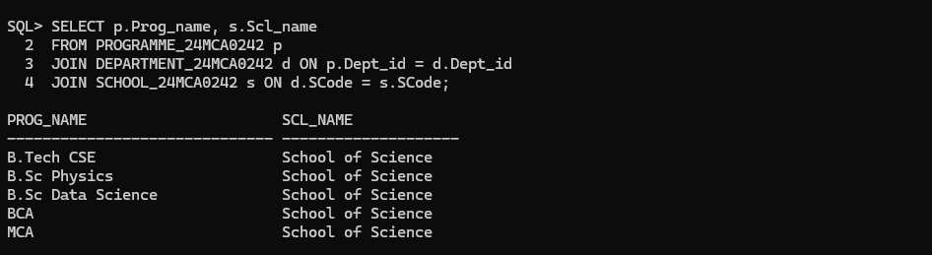

1. Display the name of the departments and the name of the program controlled by the department.

SELECT d.Dname AS Department_Name, p.Prog_name AS Program_Name FROM DEPARTMENT_24MCA0242 d JOIN PROGRAMME_24MCA0242 p ON d.Dept_id = p.Dept_id;

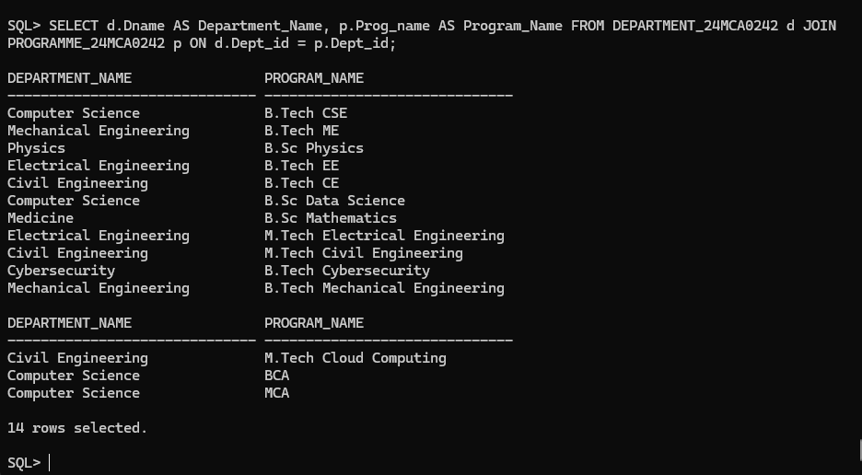

1. Find the school which has highest school strength (i.e number of students)

SELECT Scl_name FROM (

SELECT s.Scl_name, COUNT(st.Reg_no) AS student_count

FROM SCHOOL_24MCA0242 s

JOIN DEPARTMENT_24MCA0242 d ON s.SCode = d.SCode

JOIN STUDENT_24MCA0242 st ON d.Dept_id = st.Dept_id

GROUP BY s.Scl_name

ORDER BY student_count DESC)

WHERE ROWNUM = 1;

